Properties of Waves Notes
Label the axes and the following parts of the wave on the diagram below
Wavelength Amplitude Equilibrium Crest Trough

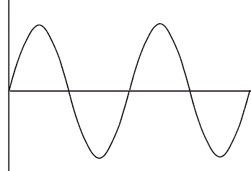

 | Definition | Symbol | Units | Equation relating to other quantities
Wavelength

Frequency

Period

Speed

Intensity

Longitudinal Waves | Transverse Waves

Mechanical Waves | Electromagnetic Waves

