**Uncertainty and Error in Measurement Notes**

**Measurement Uncertainty**

* For a single measurement, the uncertainty is determined by the instrument used to make the measurement
  + For a digital instrument, the uncertainty is equal to the smallest digit.
    - Ex: A digital balance reads 3.45 g. The uncertainty is: _________________________
  + For an analog instrument (one with a scale, like a ruler or a triple beam balance), the uncertainty is equal to half the smallest increment on the scale
    - Ex: A triple beam balance reads to 0.01 g. The uncertainty is: ________________
  + Analog instruments where both the zero and the measured value are measured (for example, you use both ends of the ruler to measure the length of an object) have double the uncertainty, equal to the smallest increment on the scale
    - Ex: A ruler reads an object as 3.45 cm long. The uncertainty is: _______________
* For multiple measurements, the measurement uncertainty is estimated by looking at the mean and the range of values measured. The IB approximates the standard deviation with half the range: (max – min)/2.
  + Ex: You measure the length of a dowel five times and get the values below.
    - Measurements: 3.25 cm, 3.02 cm, 3.57 cm, 3.18 cm 3.44 cm
    - The “measured value” (mean) is _________________________
    - The “uncertainty” (range / 2) is ___________________________

**Precision vs. Accuracy**

* A measurement is precise if there is a high degree of reproducibility. A set of measurements is considered precise if they are grouped tightly together.
  + The precision of a measurement can be evaluated by comparing the uncertainty of the measurement to the size of the measurement
    - % uncertainty = uncertainty / measured value * 100%
    - The precision of a single measurement is limited by the uncertainty of the instrument used.
      * Ex: In the digital scale example above, the percent uncertainty is: _____________.
    - The precision of multiple measurements is related to the spread in the measurements (the range/2, or (max – min)/2).
      * Ex: In the length example above, the percent uncertainty is: _______________________ .
* A measurement is accurate if it is close to the true value.
  + It is difficult to evaluate whether a measurement is accurate without comparing it to measurements of the same quantity made by other scientists using similar and different methods. This is one of the reasons that it very important for scientists to communicate their results to other scientists working on similar problems, and why scientists must sometimes attempt to duplicate each others’ results.

**Types of Measurement Errors**

|  |  |  |
| --- | --- | --- |
| **Error Type** | **What is it?** | **How can it be reduced?** |
| **Reading Error** | **Instrument Uncertainty**   * Analog: half of the smallest increment   + Ex: a ruler marked to 1 mm has a reading error of ±0.5 mm * Digital: the smallest division the device reads   + Ex: a stopwatch that reads two decimal places has an reading error of ±0.01 s |  |
| **Random Error** | **Uncertainty in the object being measured**   * Causes lots of small variation in the value read |  |
| **Systematic Error** | **Something is wrong with the measuring instrument or method**   * Often miscalibration or “zero error” |  |

**Ways of describing Uncertain Measurements**

* **Measurement** – the mean of your readings
* **Measurement Uncertainty**: ±(max measurement – min measurement) / 2
  + 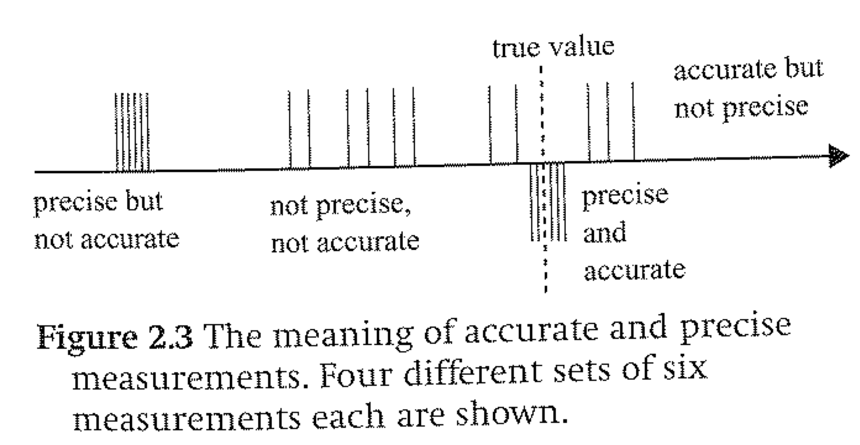Ex: You measure a length several times and get a range between 13.92 cm and 14.04 cm. The uncertainty would be ±(14.04 cm – 13.92 cm) / 2 = ±0.06 cm
* **Precision** – how much reading and random error is in the measurement
  + Very precise readings have small random and reading errors (lots of sig figs)
* **Accuracy** – how much systematic error there is in the measurement
  + Very accurate readings have small systematic errors – they are very close to the true value

**Propagating Uncertainty in Calculated Quantities**

|  |  |  |
| --- | --- | --- |
| **Operation** | **Rule** | **Example** |
| **Adding or subtracting** | Add the absolute uncertainties | (4.3 ± 0.2 cm) – (2.1 ± 0.2 cm)  = (4.3 – 2.1) ± (0.2 + 0.2) cm  = 2.2 ± 0.4 cm |
| **Multiplying, dividing, or powers** | Add the percentage uncertainties | (4.3 ± 0.2 cm) * (2.1 ± 0.2 cm)  = (4.3 cm ± 0.2/4.3) * (2.1 cm ± 0.2/2.1)  = (4.3 cm ± 5%) * (2.1 cm ± 10%)  = 4.3 cm * 2.1 cm ± (5% + 10%)  = 9.0 cm2 ± 15%  = 9.0 cm2 ± (15%*9.0 cm2)  = 9.0 ± 1.4 cm2 |
| **Other functions (trig functions, etc.)** | Crank 3 Times – find the max, mean, and min values and use to find the range | sin(35 ± 5°) = ?  sin(35 + 5°) = sin (40.°) = 0.64 (max)  sin(35°) = 0.57 (mean)  sin(35 - 5°) = sin(30.°) = 0.50 (min)  sin(35 ± 5°)  = 0.57 ± 0.7 (mean ± (max – min)/2) |

**Showing Uncertainty in IB Data Table Headings**

For IB Science, every data table column must have a heading that includes the following three elements:

1. Quantity measured (Ex: Length 1)
2. Variable for the quantity measured (Ex: L1)
3. Unit (Ex: cm)
4. Initial Uncertainty (Ex: ±0.05 cm)

These combine to a column header that looks something like this:

Length 1

L1/ cm

±0.05 cm

The initial uncertainty will usually be the reading error or measurement error (see below) of the instrument you are using. Sometimes you may find that the human part of the measurement system (for example, human reaction time in triggering a stopwatch) is greater than the reading error. In that case, you should estimate the error in the human part of the system, use that for your initial uncertainty, and explain in your lab write-up how you chose that value.

**Notes for Internal Assessment Data**

* For all IB Internal Assessment experiments, you should plan to take at least 5 trials of any measurement (and use at least 5 values of your independent variable)
  + Your Raw Data table should have the independent variables at the far left of each row, and the trials of your dependent variable measurements and the columns
  + Each column header should include the following four elements:

1. Quantity measured (Ex: Length 1)
2. Variable for the quantity measured (Ex: L1)
3. Unit (Ex: cm)
4. Initial Uncertainty (Ex: ±0.05 cm)

These combine to a column header that looks something like this:

Length 1

L1/ cm

±0.05 cm

* + Your Processed Data table should be separate from your raw data, and include your calculated quantities
* In IB Physics, when you only take a single measurement, you should indicate your measurement uncertainty in the data table column head:

1. Quantity measured (Ex: Length of Dowl)
2. Variable for the quantity measured, used in equations (Ex: L)
3. Unit (Ex: cm)
4. Initial Uncertainty (Ex: ±0.05 cm)

These combine to a column header that looks something like this:

Length of Dowel

L/ cm

±0.05 cm

The significant digits on your measurements should be consistent with the uncertainty you indicate in the column header.

**Uncertainty Practice Questions**

(Answer on a separate sheet of paper)

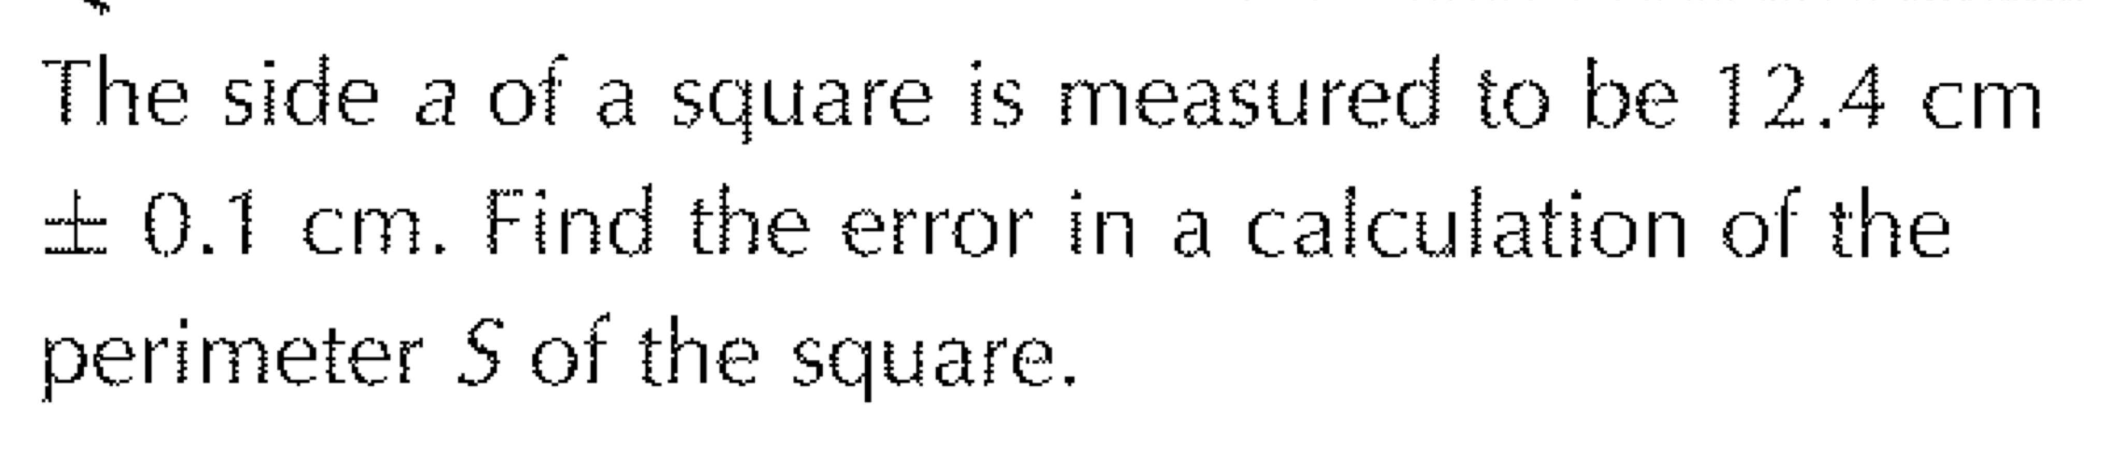

1. 6. 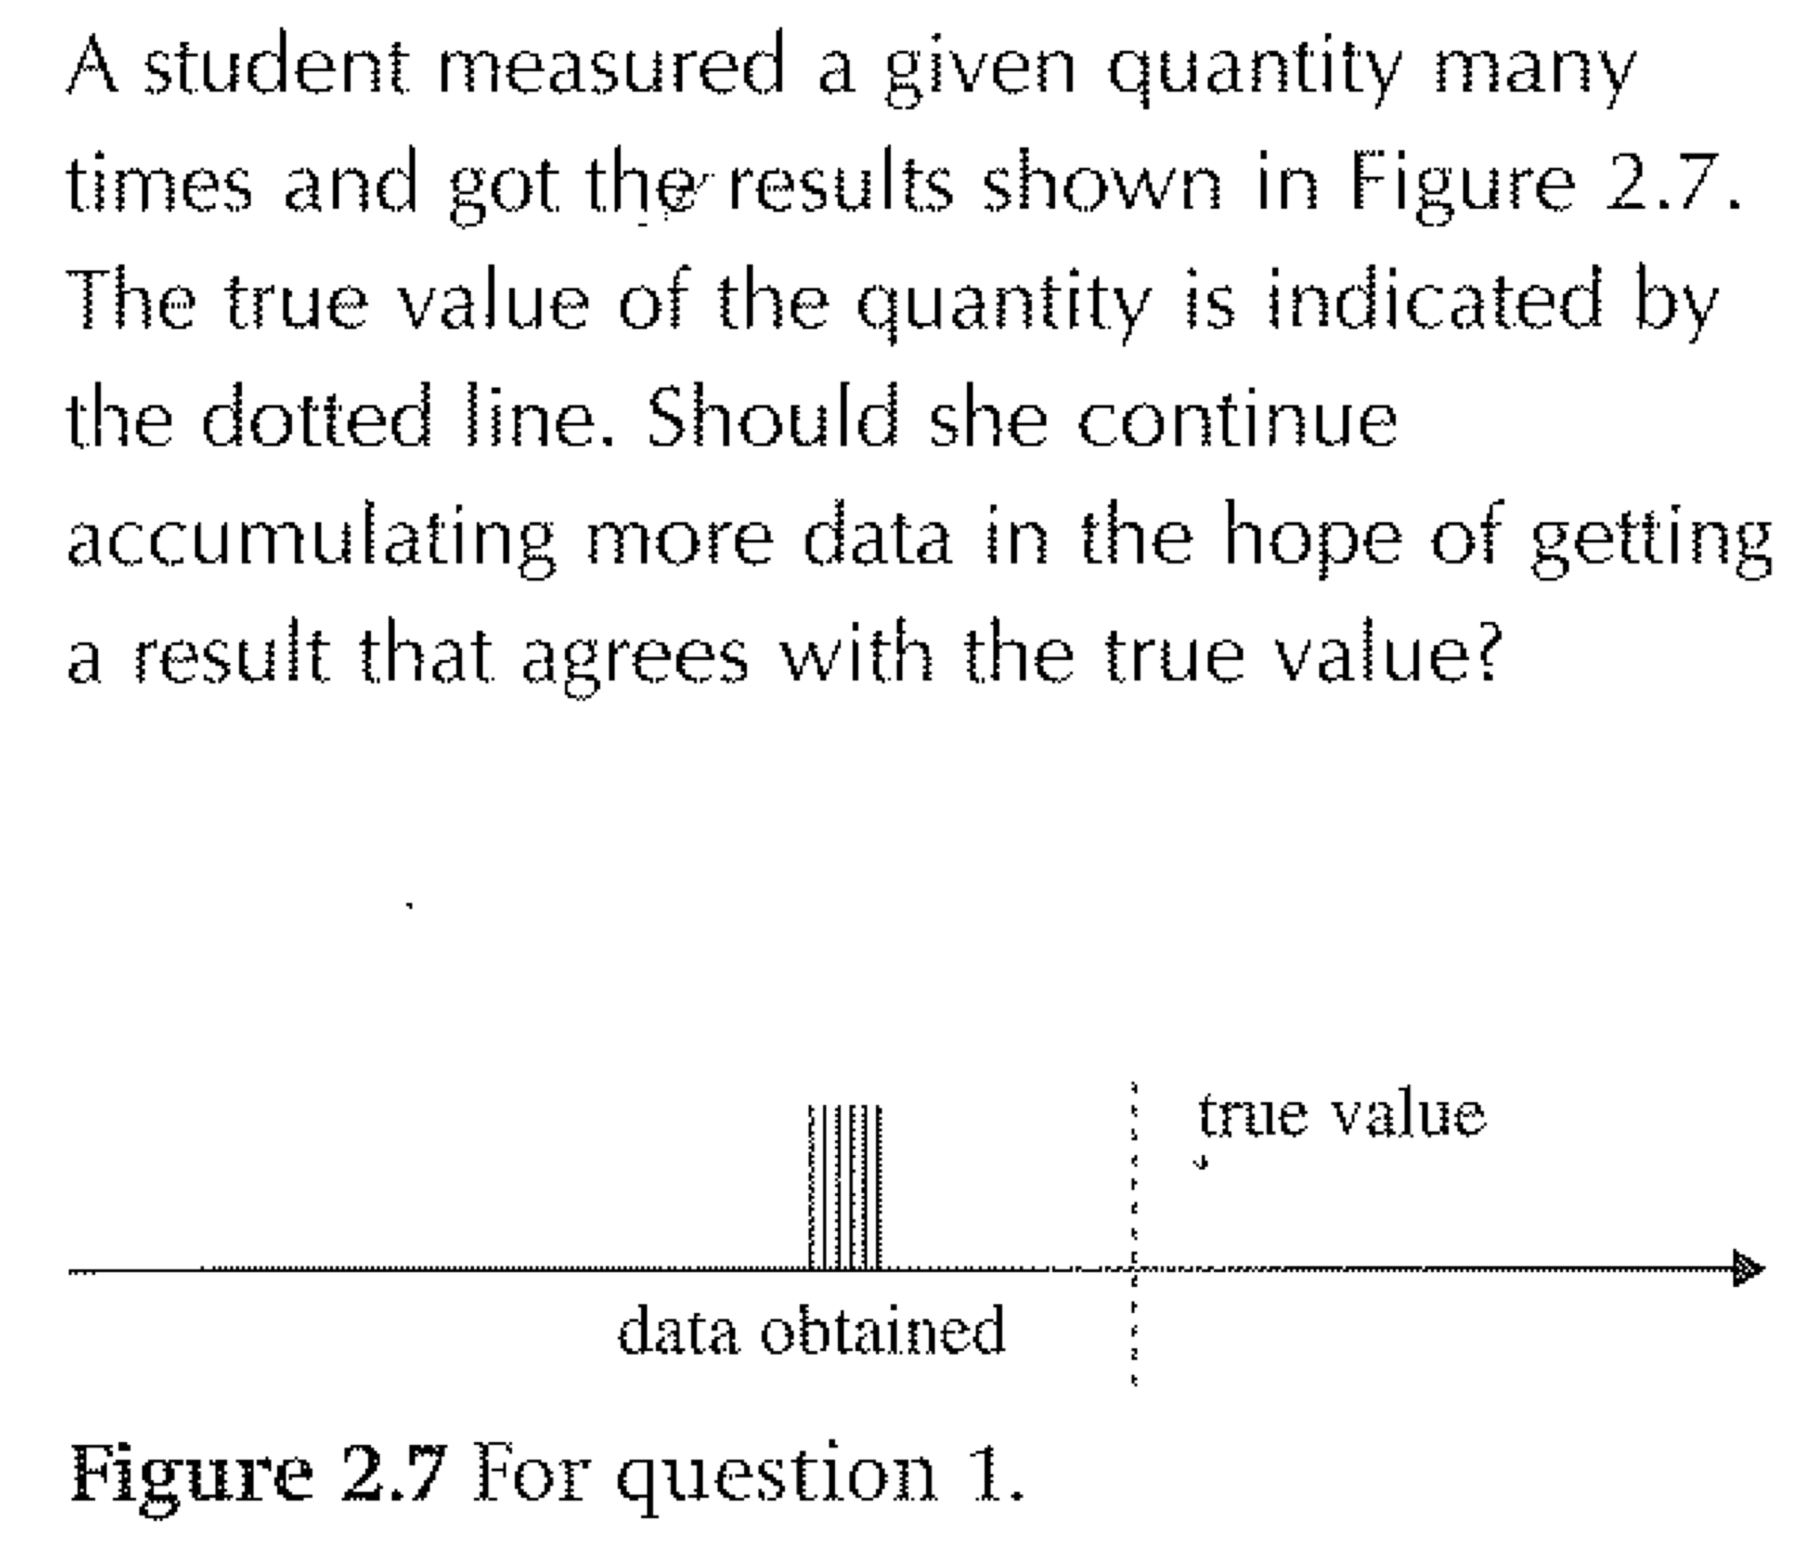

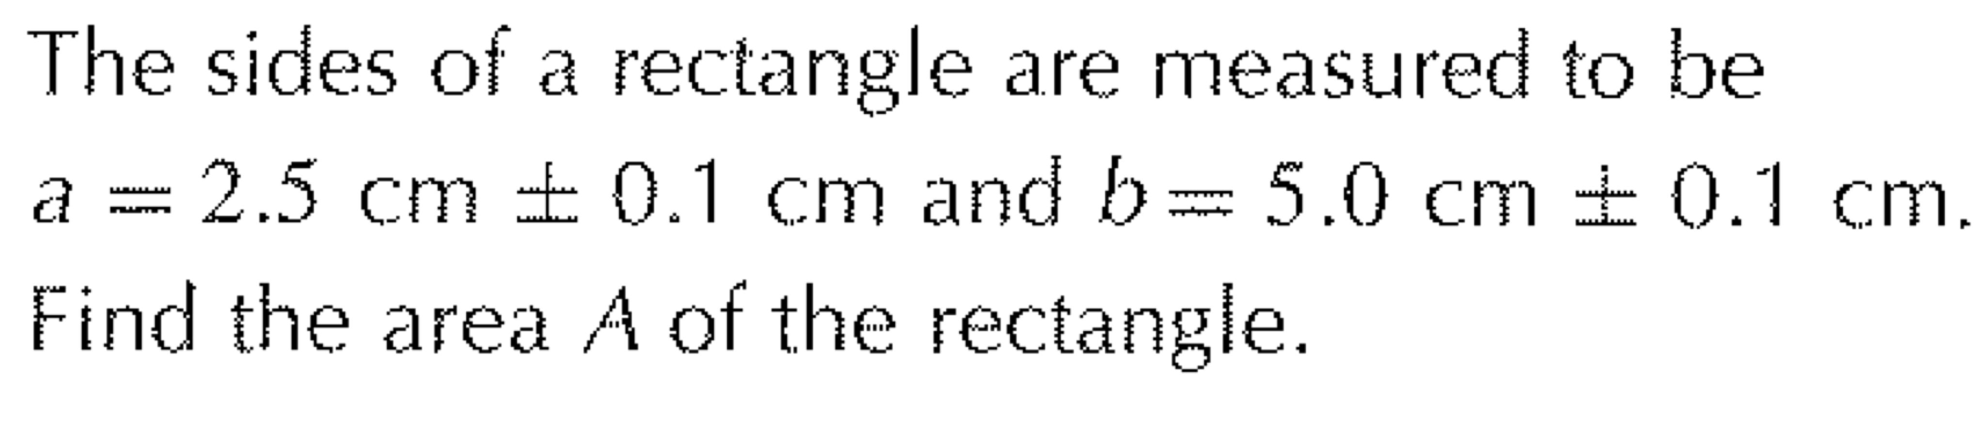

7.

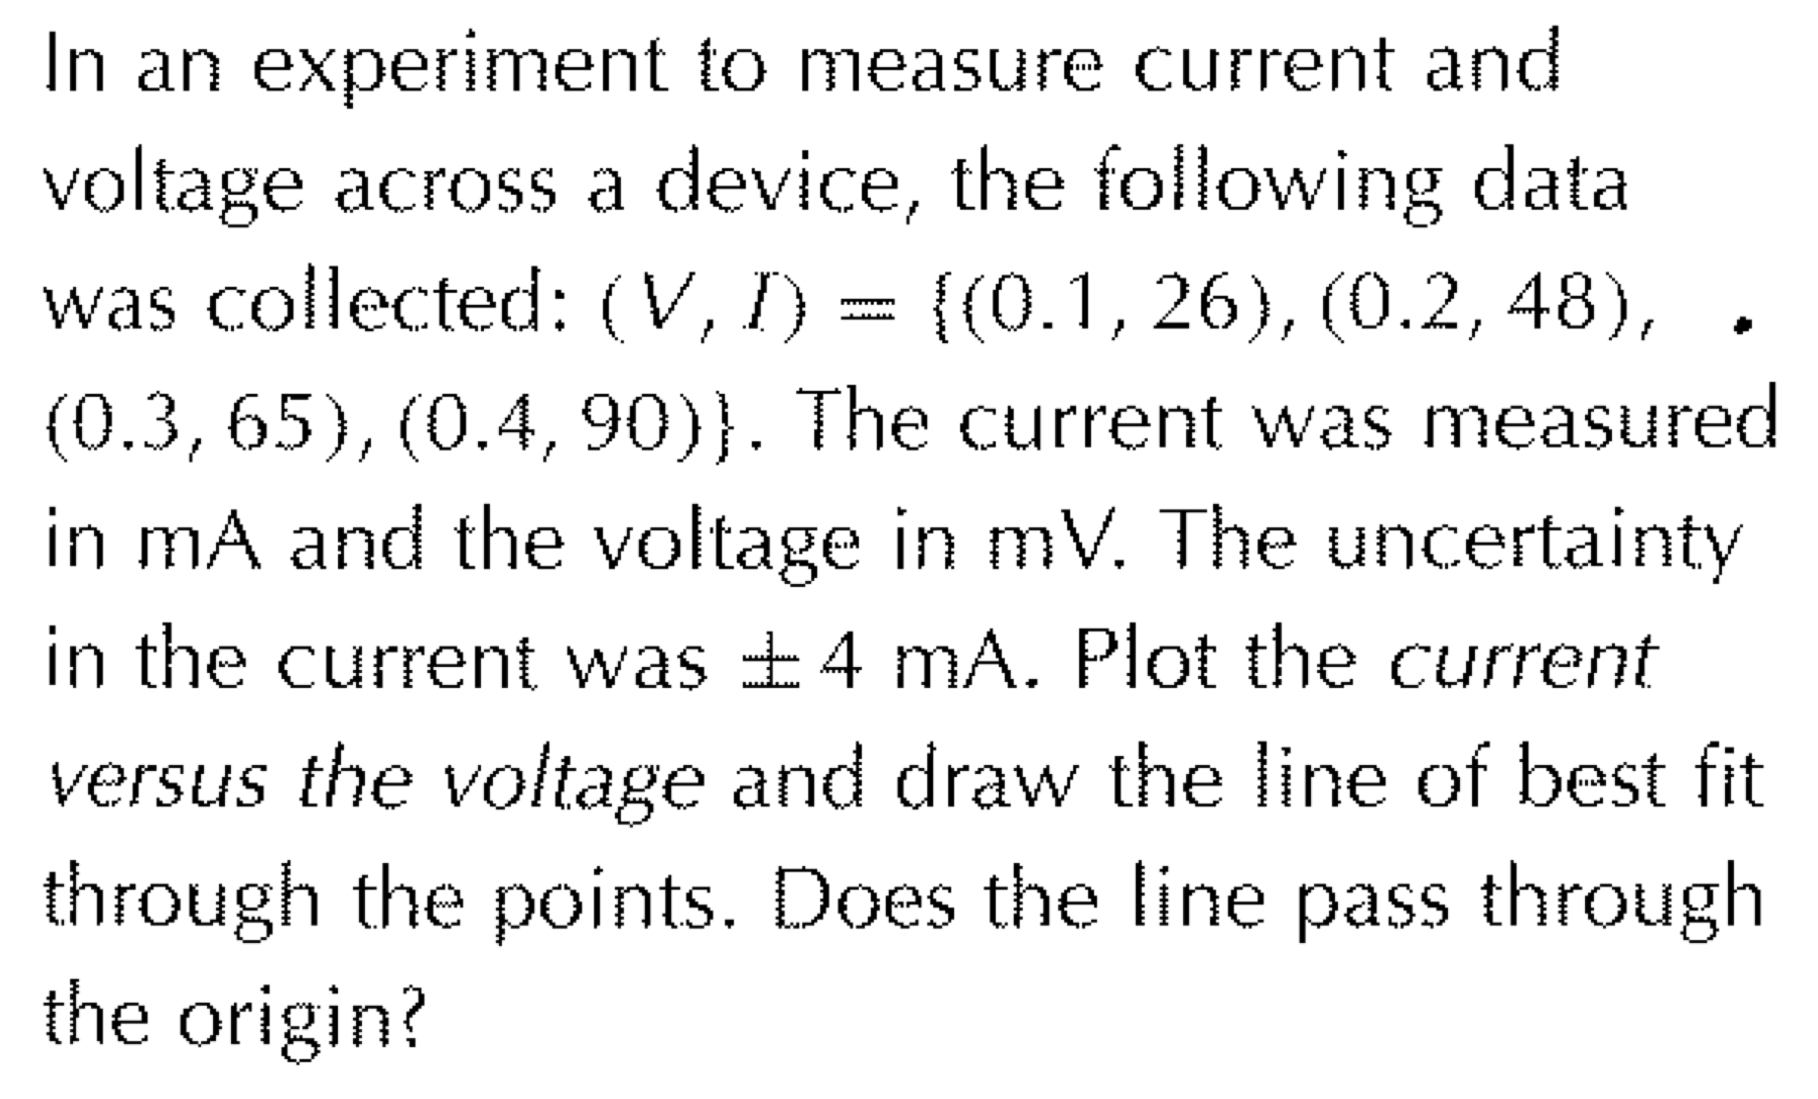

8.

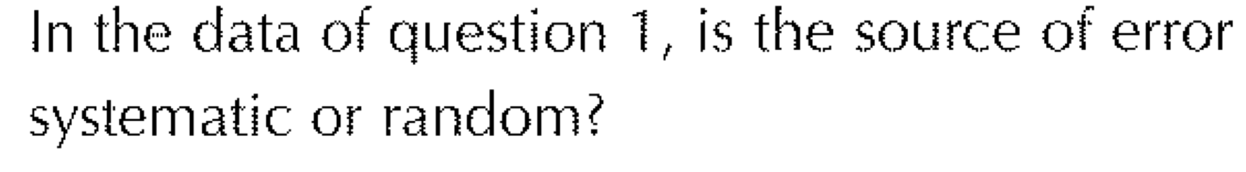

2.

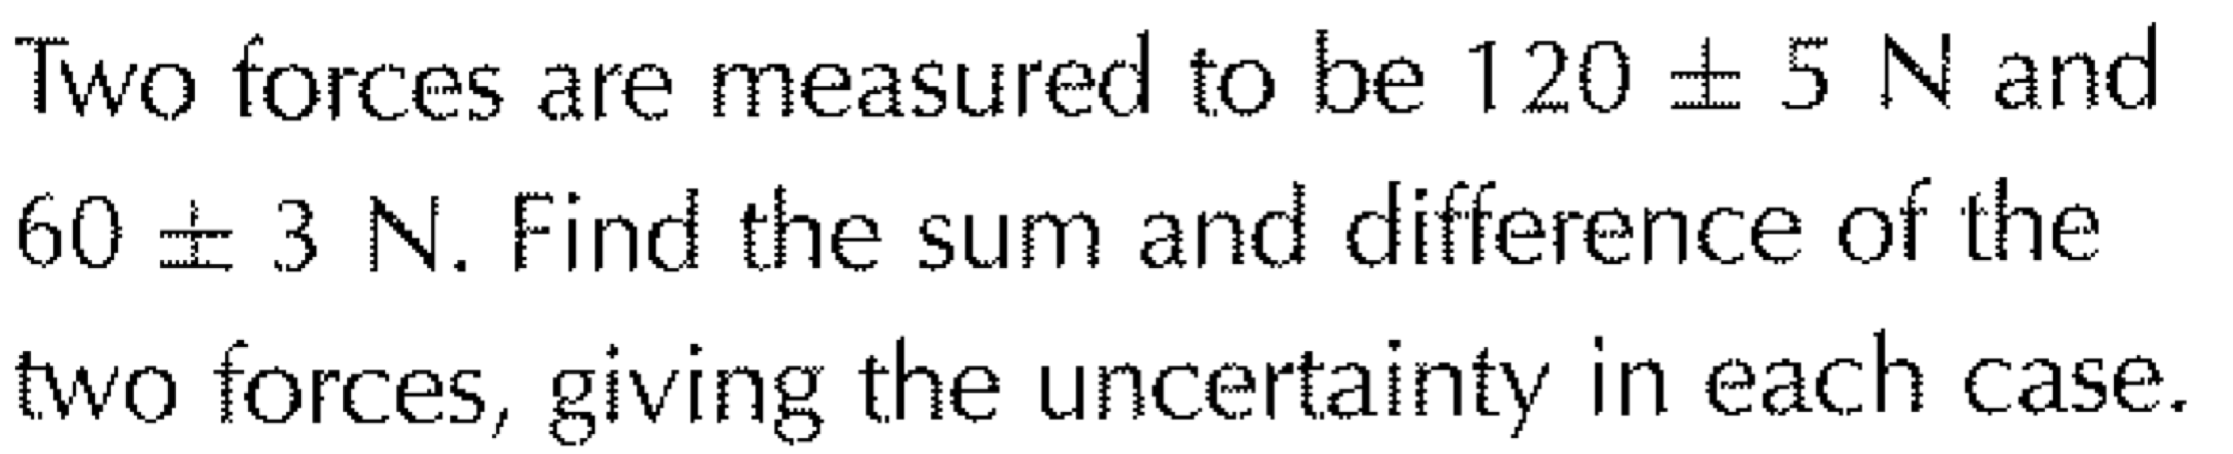3.

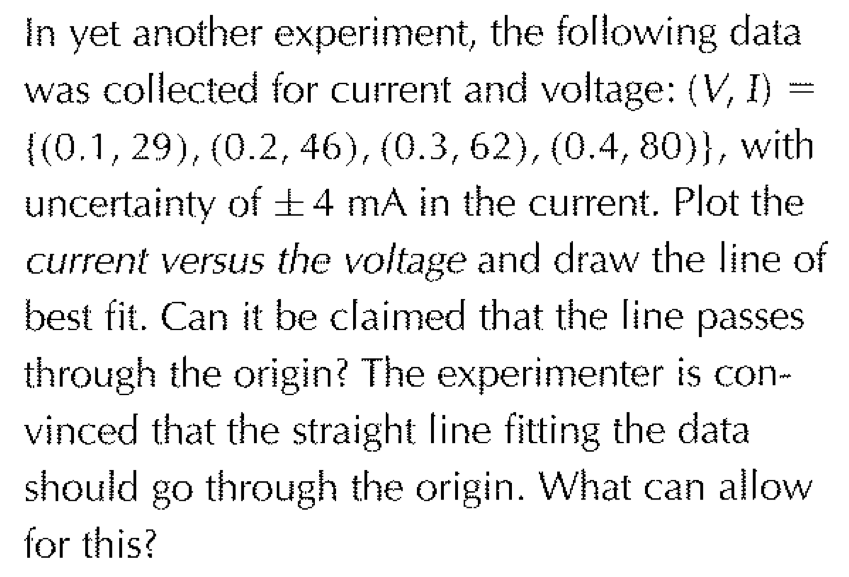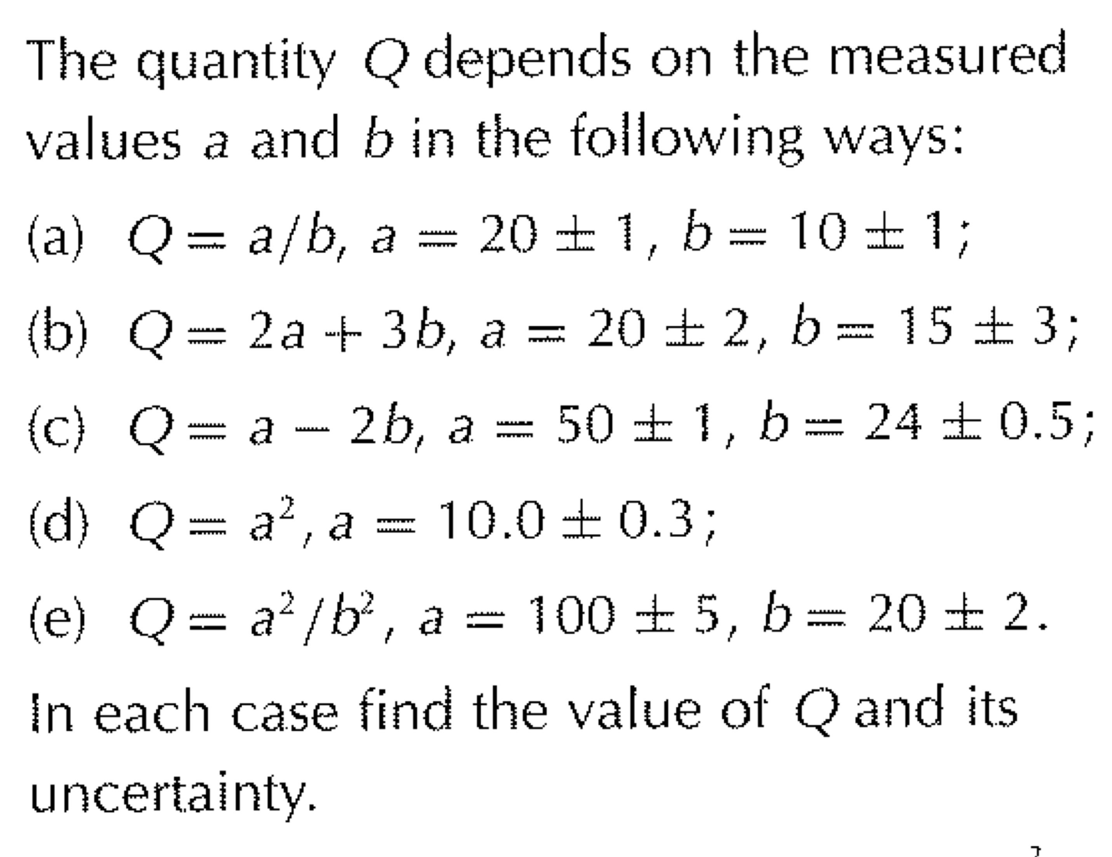

4. 9.

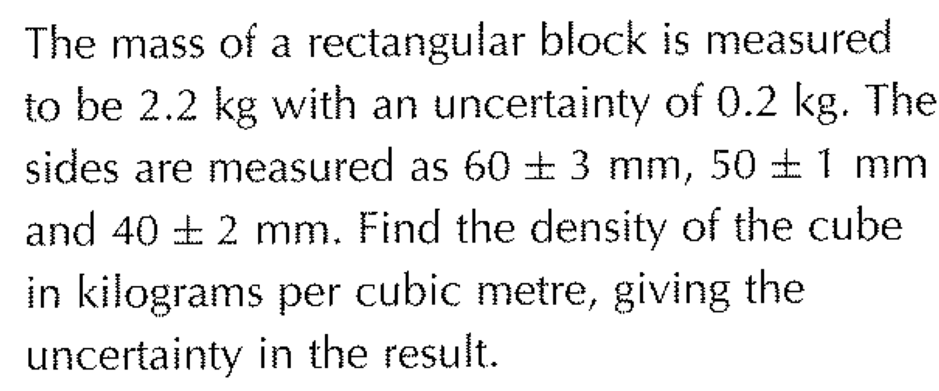

5.