Simple Harmonic Motion Lab Data
Label important time and position information.
Set Up: __________________________________________________________________________
Equilibrium Position:________________
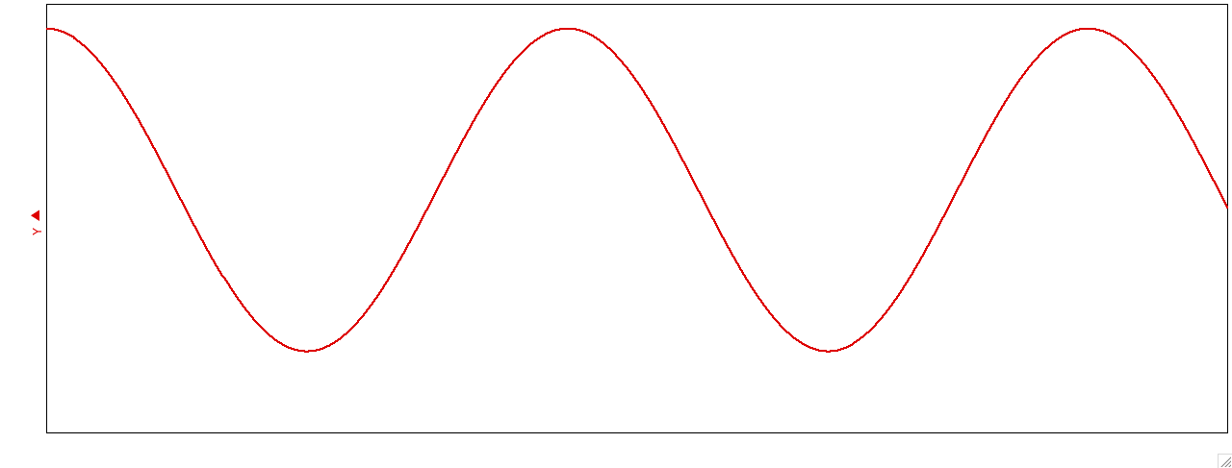
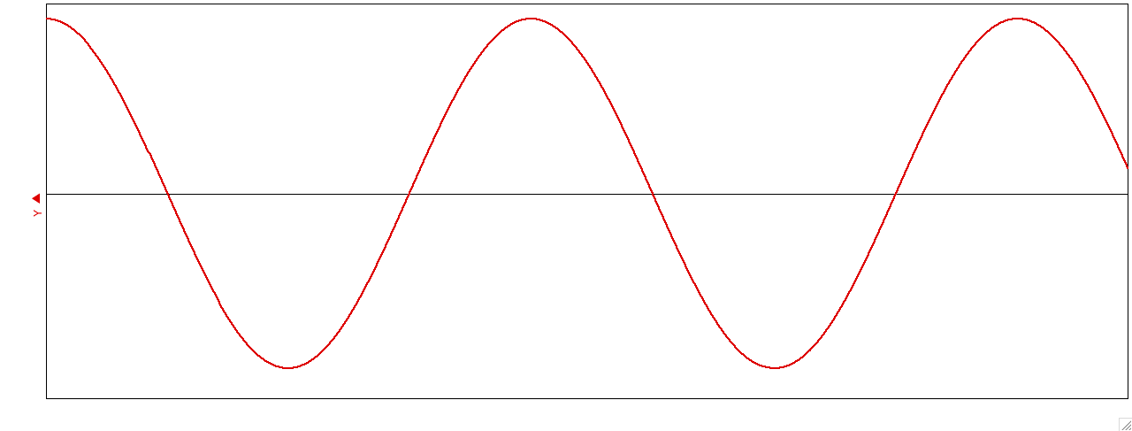
Graph as it appears on the computer
Data shifted around equilibrium

A = __________ T = __________ f = ___________ ω = __________

Set Up: __________________________________________________________________________
Equilibrium Position:________________
Graph as it appears on the computer
Data shifted around equilibrium

A = __________ T = __________ f = ___________ ω = __________

Set Up: __________________________________________________________________________
Equilibrium Position:________________
Graph as it appears on the computer
Data shifted around equilibrium

A = __________ T = __________ f = ___________ ω = __________

