Rolling

1. Describe what would happen in a race down an incline of a thin hoop, a can of chicken broth, and a can of dog food.

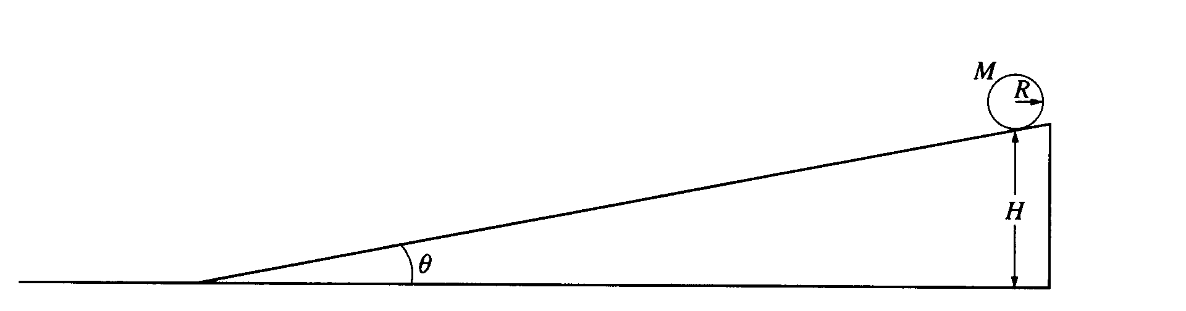
2. A solid cylinder with mass M, radius R rolls without slipping down the inclined plane shown above. The cylinder starts from rest at a height H. The inclined plane makes an angle θ with the horizontal. Express all solutions in terms of M, R, H, θ, and g.
a. Determine the translational speed of the cylinder when it reaches the bottom of the inclined plane.
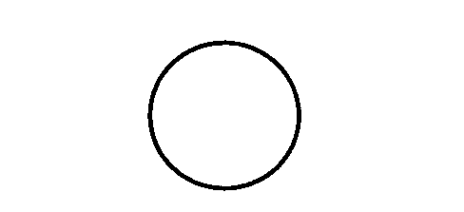
b. Draw and label the forces acting on the cylinder as it rolls down the inclined plane Your arrow should begin at the point of application of each force.

c. Show that the acceleration of the center of mass of the cylinder while it is rolling down the inclined plane is (2/3)g sinθ.
d. Determine the minimum coefficient of friction between the cylinder and the inclined plane that is required for the cylinder to roll without slipping.
e. The coefficient of friction μ is now made less than the value determined in part (d), so that the cylinder both rotates and slips.
i. Indicate whether the translational speed of the cylinder at the bottom of the inclined plane is greater than, less than, or equal to the translational speed calculated in part (a). Justify your answer.
ii. Indicate whether the total kinetic energy of the cylinder at the bottom of the inclined plane is greater than, less than, or equal to the total kinetic energy for the previous case of rolling without slipping. Justify your answer.

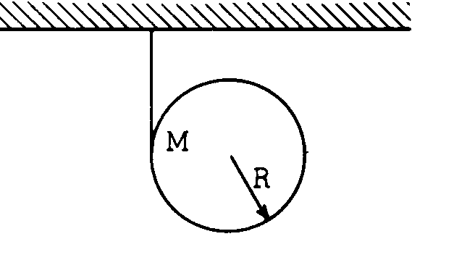
3. A cloth tape is wound around the outside of a uniform solid cylinder (mass M, radius R) and fastened to the ceiling as shown in the diagram above. The cylinder is held with the tape vertical and then released from rest. As the cylinder descends, it unwinds from the tape without slipping.

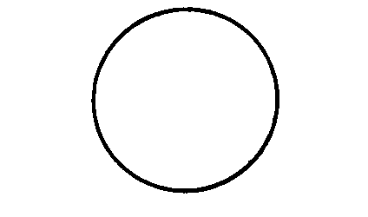
a. On the circle at right, draw vectors showing all the forces acting on the cylinder after it is released. Label each force clearly.

b. In terms of g, find the downward acceleration of the center of the cylinder as it unrolls from the tape.

4. A block of mass m slides up the incline shown above with an initial speed v_{O} in the position shown.
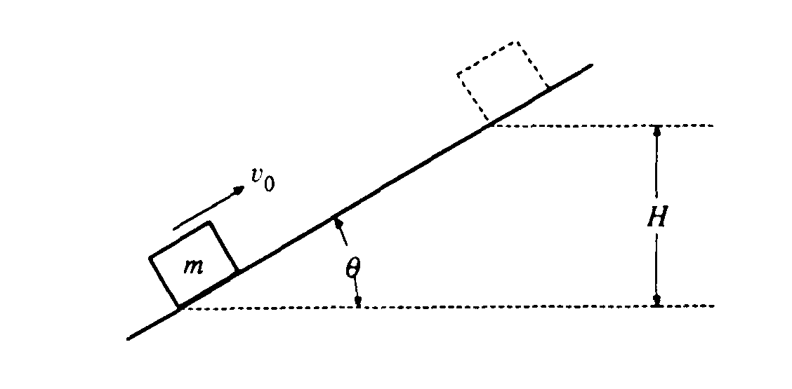
a. If the incline is frictionless, determine the maximum height H to which the block will rise, in terms of the given quantities and appropriate constants.
b. If the incline is rough with coefficient of sliding friction μ, determine the maximum height to which the block will rise in terms of H and the given quantities.
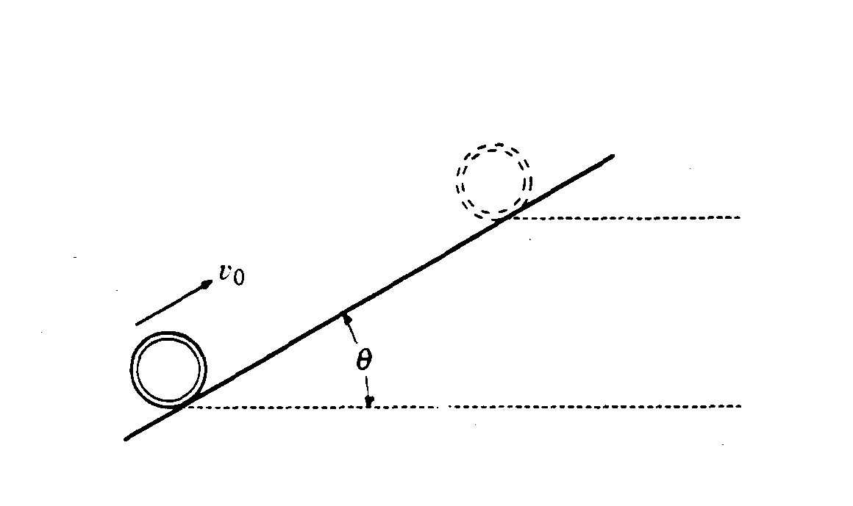
A thin hoop of mass m and radius R moves up the incline shown above with an initial speed v_{O} in the position shown.
c. If the incline is rough and the hoop rolls up the incline without slipping, determine the maximum height to which the hoop will rise in terms of H and the given quantities.
d. If the incline is frictionless, determine the maximum height to which the hoop will rise in terms of H and the given quantities.

5. A 1200 kg airplane is flying in a straight line at 80 m/s, 1.3 km above the ground. What is the angular momentum of the airplane with respect to a person on the ground directly below the plane’s flight path?

6. When a figure skater rotates with her arms out, she has a moment of inertia of 1.5 kgm². When she brings her arms in for a tight spin, she has a moment of inertia of 0.6 kgm². When spinning with her arms out, her angular velocity is 12 rad/s.
a. What would her final velocity be after she brings her arms close to her body?
b. What is her initial kinetic energy?
c. What is her final kinetic energy?
d. Where did the energy come from?

