Oscillations II
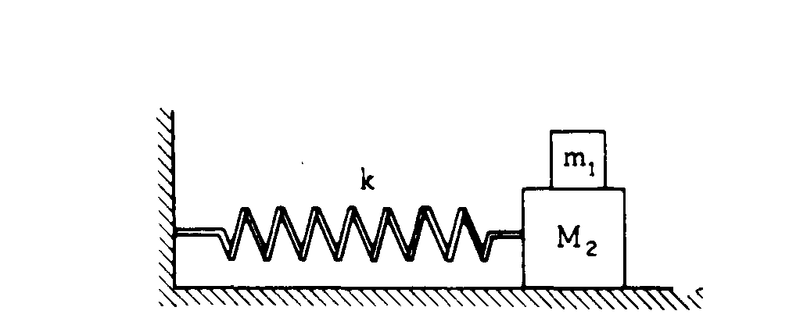
1. A small mass m₁ rests on but is not attached to a large mass M₂ that slides on its base without friction.
The maximum frictional force between m₁ and M₂ is f. A spring of spring constant k is attached to the
large mass M₂ and to the wall as shown above.
a. Determine the maximum horizontal acceleration that M₂ may have without causing m₁ to slip.
b. Determine the maximum amplitude A for simple harmonic motion of the two masses if they are to move together, i.e., m₁ must not slip on M₂.
c. The two-mass combination is pulled to the right the maximum amplitude A found in part (b) and released. Describe the frictional force on the small mass m₁ during the first half cycle of oscillation.
d. The two-mass combination is now pulled to the right a distance of A' greater than A and released.
i. Determine the acceleration of m₁ at the instant the masses are released.
ii. Determine the acceleration of M₂ at the instant the masses are released.

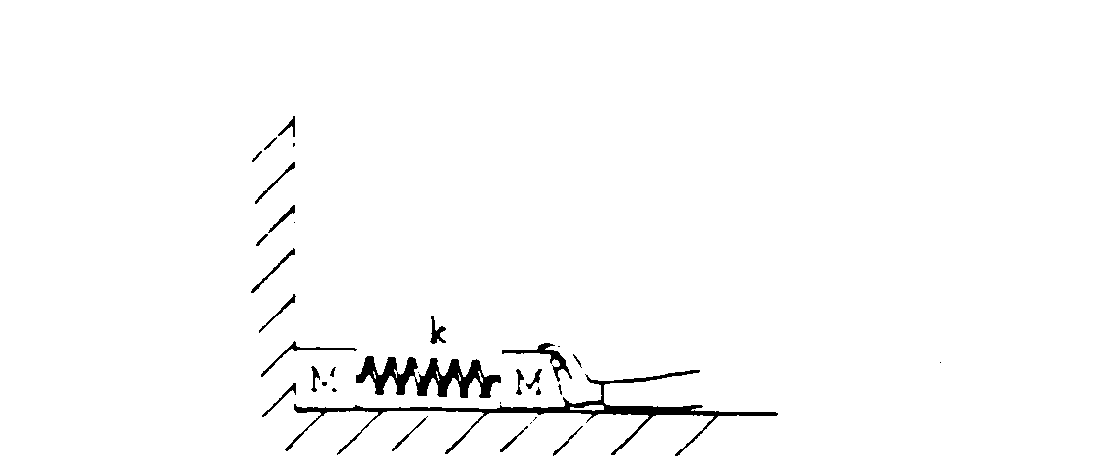
2. A system consists of two blocks, each of mass M, connected by a spring of force constant k. The system is initially shoved against a wall so that the spring is compressed a distance D from its original uncompressed length. The floor is frictionless. The system is now released with no initial velocity.
a. Determine the maximum speed of the right-hand block.
b. Determine the speed of the center of mass of the system when the left-hand block is no longer in contact with the wall
c. Determine the period of oscillation for the system when the left-hand block is no longer in contact with
the wall
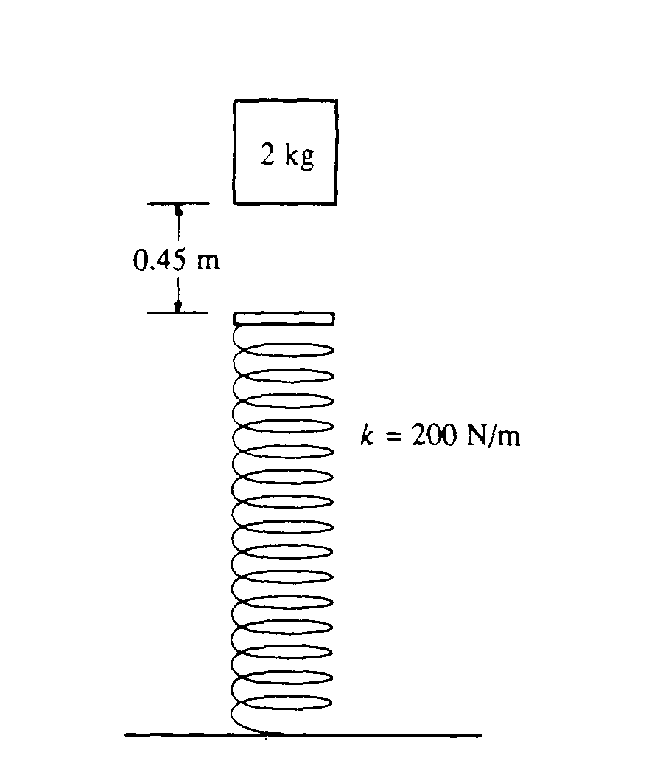

3. A 2-kilogram block is dropped from a height of 0.45 meter above an uncompressed spring, as shown above. The spring has an elastic constant of 200 newtons per meter and negligible mass. The block strikes the end of the spring and sticks to it.
a. Determine the speed of the block at the instant it hits the end of the spring.
b. Determine the period of the simple harmonic motion that ensues.
c. Determine the distance that the spring is compressed at the instant the speed of the block is maximum.
d. Determine the maximum compression of the spring.
e. Determine the amplitude of the simple harmonic motion.

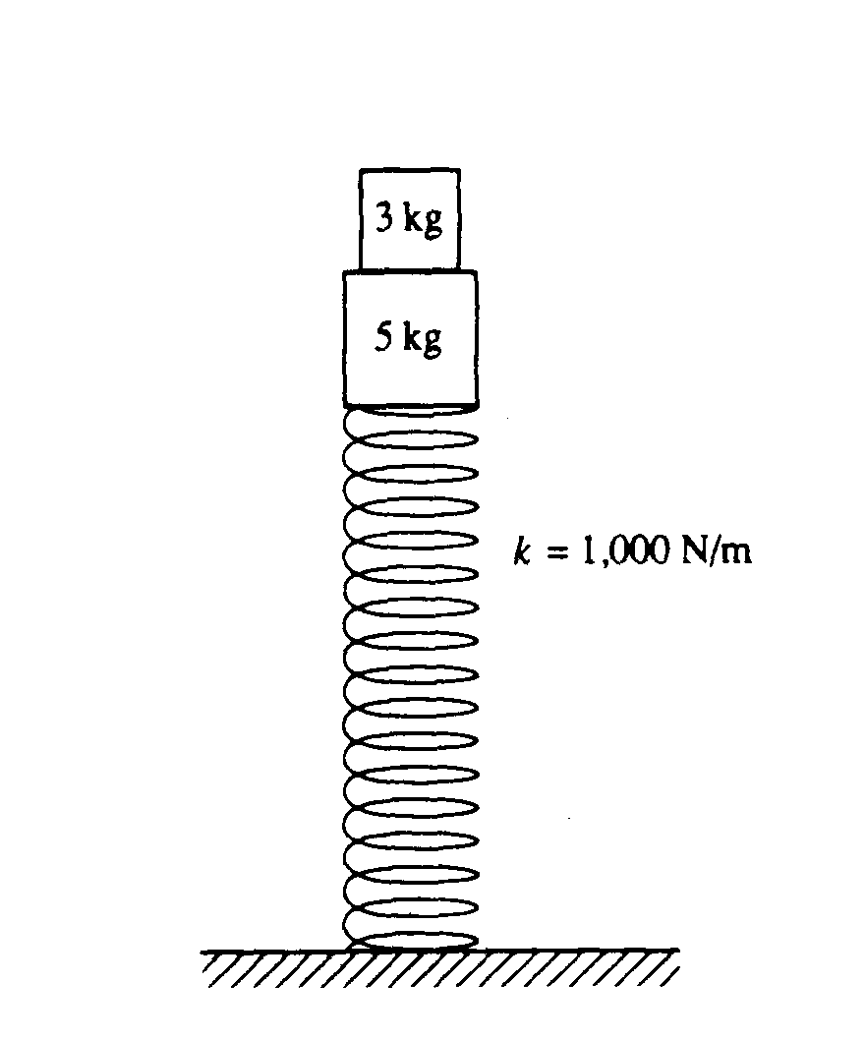
4. A 5-kilogram block is fastened to a vertical spring that has a spring constant of 1,000 newtons per meter. A 3-kilogram block rests on top of the 5-kilogram block, as shown above.
a. When the blocks are at rest, how much is the spring compressed from its original length?

The blocks are now pushed down and released so that they oscillate.
b. Determine the frequency of this oscillation.
c. Determine the magnitude of the maximum acceleration that the blocks can attain and still remain in contact at all times.
d. How far can the spring be compressed beyond the compression in part (a) without causing the blocks to exceed the acceleration value in part (c) ?
e. Determine the maximum speed of the blocks if the spring is compressed the distance found in part (d).

5. You are conducting an experiment to measure the acceleration due to gravity g_{u} at an unknown location. In the measurement apparatus, a simple pendulum swings past a photogate located at the pendulum’s lowest point, which recors the time t₁₀ for the pendulum to undergo 10 full oscillations. The pendulum consists of a sphere of mass m at the end of a string and has a length l. There are four versions of this apparatus, each with a different length. All four are at the unknown location, and the data shown are sent to you during the experiment.

a. For each pendulum, calculate the period T and the square of the period. Use a reasonable number of significant figures. Enter these results in the table above.

b. On the axes below, plot the square of the period versus the length of the pendulum. Draw a best-fit straight line for this data.
c. Assuming that each pendulum undergoes small amplitude oscillations, from your fit determine the experimental value g_{exp} of the acceleration due to gravity at this unknown location. Justify your answer.

d. If the measurement apparatus allows a determination of g_{u} that is accurate to within 4%, is your experimental value in agreement with the value 9.80 m/s²? Justify your answer.

e. Someone informs you that the experimental apparatus is in fact near Earth’s surface, but that the experiment has been conducted inside an elevator with a constant acceleration a. Assuming that your experimental value g_{exp} is exact, determine the magnitude and direction of the elevator’s acceleration.

