***Lenses Lab***

The thin lens equation describes the relationship between the object distance, image distance and focal length. 

**Part I:**  Drawing a Ray Diagram for Converging Lenses

From top of object, draw three rays through the lens:

In parallel to optical axis 🡪 out to focal point

In center of lens 🡪 out of center of lens

In through focal point of lens 🡪 out parallel to optical axis

Example:

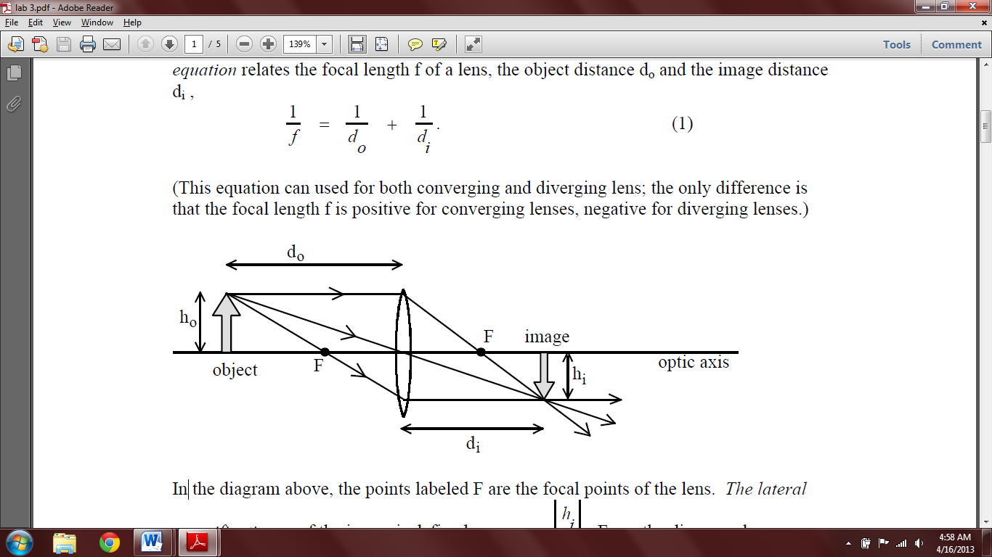

Draw a ray diagram for each of the figures below. Measure the distance of the focal point, the object distance and height. Check to see your diagram matches your calculations.

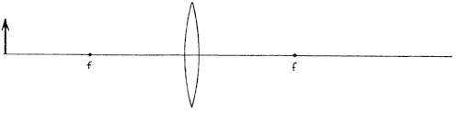

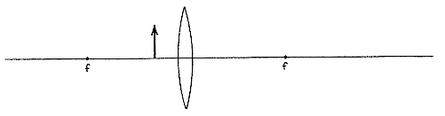**Part II:** Finding the Focal Point of a Converging Lens

Procedure

1. Place the lamp-box well outside the approximate focal length.

2. Move the screen until a **clear** inverted image of the crosswire is obtained.

3. Measure the distance do from the crosswire to the lens.

4. Measure the distance di from the screen to the lens.

5. Calculate the focal length of the lens.

6. Calculate the image height.

7. Measure the actual image height.

8. Calculate percent difference between the actual height and the predicted height of the image using [(measured – calculated) / calculated] x 100

6. Repeat this procedure for a different value of do by only moving the lens. Do not move the light source.

7. Calculate f and hi each time. Find the average value of f.

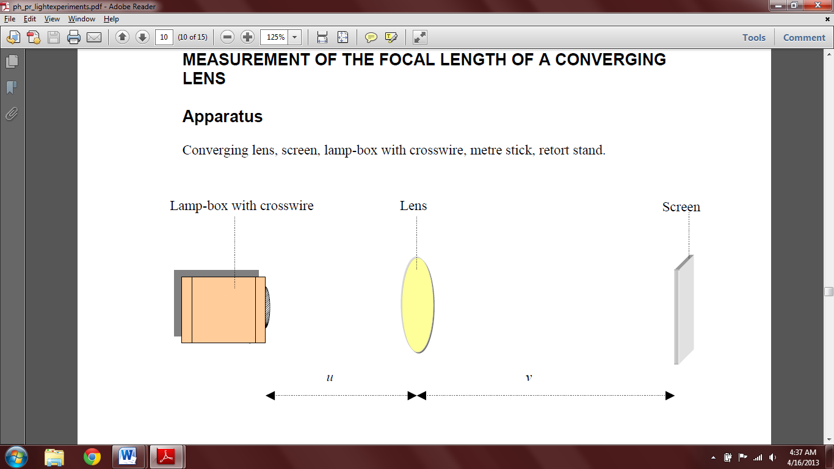

do di

|  |  |  |  |  |  |  |
| --- | --- | --- | --- | --- | --- | --- |
| do (cm) | di (cm) | f (cm) | ho (cm) | Calculated  hi (cm) | Measured  hi (cm) | % difference |
|  |  |  |  |  |  |  |
|  |  |  |  |  |  |  |

Average f = cm

What do you notice about the orientation of the second image? Is it upright or inverted?

What do you notice about the object distance in the first case in relation to the image distance in the second case?