Gravitation I

1. A rocket has a constant thrust. Describe the acceleration of the rocket over time, addressing mass and height.

2. The space shuttle orbits at an altitude of approximately 400 km.
a. What is the speed of the shuttle in orbit?
b. How many orbits does the shuttle make each day?

3. Show that Newton’s Law of Gravitation leads to Kepler’s Third Law of Planetary Motion.

4. What is the period of a 1.2 meter pendulum on the surface of Mars?

5. What is the distance between the Earth and the Moon where a satellite would be in gravitational equilibrium?

6. A geosynchronous satellite stays directly above a single point on the Earth. Assume the mass of the satellite is 2500 kg.
a. What is the altitude for the satellite?
b. What is the potential energy for the Earth-satellite system?
c. What is the total mechanical energy for the Earth-satellite system?

7. A theoretical asteroid is a uniform, solid sphere with a radius of 140 km and mass of 8.0X10¹⁸ kg.
a. How much would a 75 kg astronaut weigh on the surface of the asteroid?
b. How much would the same astronaut weigh 20 km below the surface?
c. How much would the same astronaut weigh 20 km above the surface?

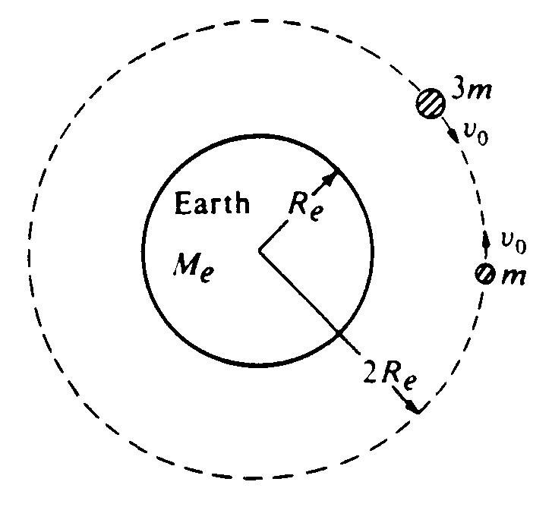
8. Two satellites, of masses m and 3m, respectively, are in the same circular orbit about the Earth's center, as shown in the diagram above. The Earth has mass M_{e} and radius R_{e}. In this orbit, which has a radius of 2R_{e}, the satellites initially move with the same orbital speed v_{o} but in opposite directions.
a. Calculate the orbital speed v_{o} of the satellites in terms of G, M_{e}, and R_{e}.
b. Assume that the satellites collide head-on and stick together. In terms of v_{o} find the speed v of the combination immediately after the collision.
c. Calculate the total mechanical energy of the system immediately after the collision in terms of G, m, M_{e}, and R_{e}. Assume that the gravitational potential energy of an object is defined to be zero at an infinite distance from the Earth.

9. Two stars each of mass M form a binary star system such that both stars move in the same circular orbit of radius R. The universal gravitational constant is G.
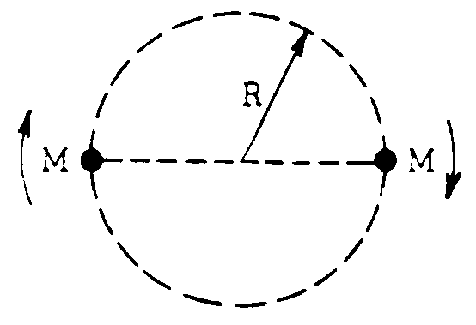
a. Use Newton's laws of motion and gravitation to find an expression for the speed v of either star in terms of R, G, and M.
b. Express the total energy E of the binary star system in terms of R, G, and M.

Suppose instead, one of the stars had a mass 2M.
c. On the following diagram, show circular orbits for this star system.

2M
M

d. Find the ratio of the speeds, v_{2M}/v_{M.}

