Gravitation II

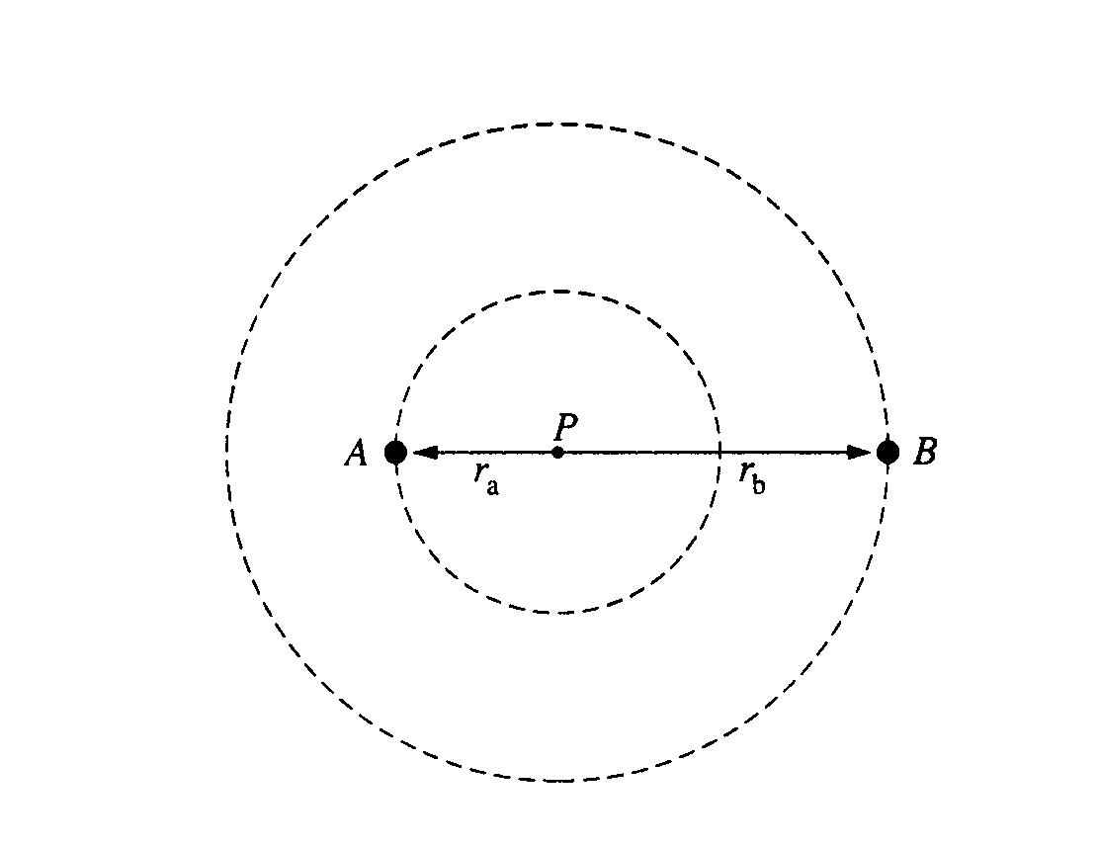
1. Two stars, A and B. are in circular orbits of radii r_{a} and r_{b}, respectively, about their common center of mass at point P, as shown above. Each star has the same period of revolution T.

Determine expressions for the following three quantities in terms of r_{a}, r_{b}, T, and fundamental constants.
a. The centripetal acceleration of star A
b. The mass M_{b} of star B
c. The mass M_{a} of star A

Determine expressions for the following two quantities in terms of M_{a}, M_{b}, r_{a}, r_{b}, T, and fundamental constants.
d. The moment of inertia of the two-star system about its center of mass.
e. The angular momentum of the system about the center of mass.

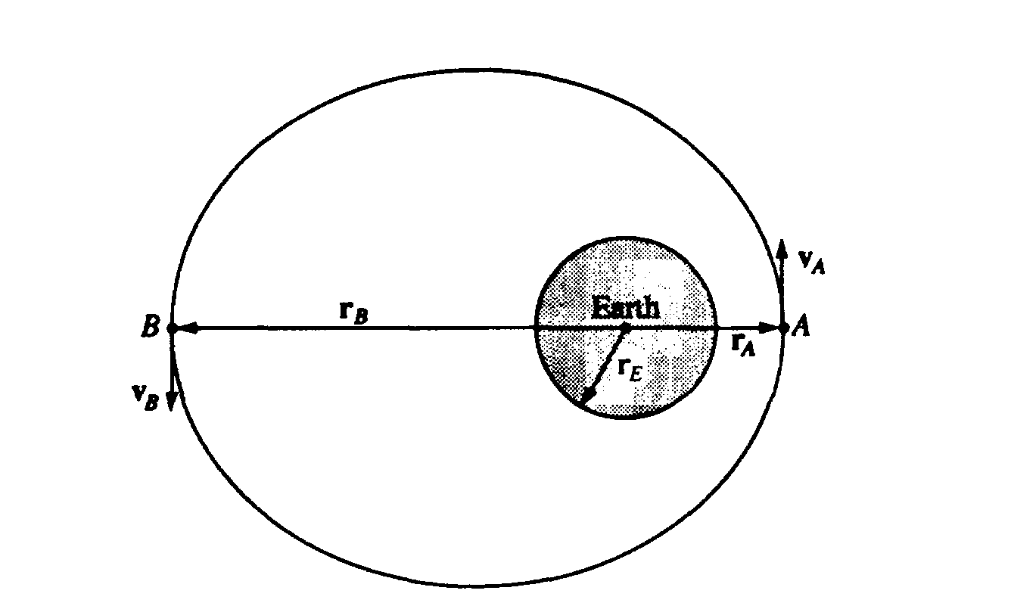2. A spacecraft of mass 1,000 kilograms is in an elliptical orbit about the Earth, as shown above. At point A the spacecraft is at a distance r_{A} = 1.2 x 10⁷ meters from the center of the Earth and its velocity, of magnitude V_{A} = 7.1 x 10³ meters per second, is perpendicular to the line connecting the center of the Earth to the spacecraft. The mass and radius of the Earth are M_{E} = 6.0 X 10²⁴ kilograms and r_{E} = 6.4 X 10⁶ meters, respectively.
Determine each of the following for the spacecraft when it is at point A .
a. The total mechanical energy of the spacecraft, assuming that the gravitational potential energy is zero at an infinite distance from the Earth.
b. The magnitude of the angular momentum of the spacecraft about the center of the Earth.

Later the spacecraft is at point B on the exact opposite side of the orbit at a distance r_{B} = 3.6 X 10⁷ meters from the center of the Earth.
c. Determine the speed v_{B} of the spacecraft at point B.

Suppose that a different spacecraft is at point A, a distance r_{A} = 1.2 X 10⁷ meters from the center of the Earth. Determine each of the following.
d. The speed of the spacecraft if it is in a circular orbit around the Earth.
e. The minimum speed of the spacecraft at point A if it is to escape completely from the Earth.

