Case:_________________ Masses: _____________________

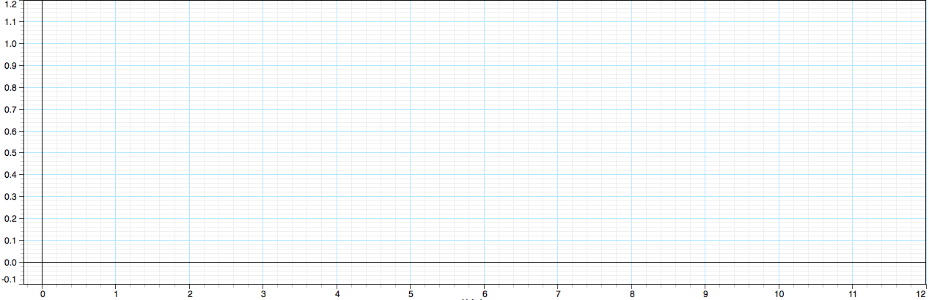
a.
b.
c. v_{i,front} = ____________________
v_{f,front} = ____________________

_ _ _ _ _ _ _ _ _ _ _ _ _ _ _ _ _ _ _ _ _ _ _ _ _ _ _ _ _ _ _ _ _ _ _ _

Case:_________________ Masses: _____________________

a.
b.
c. v_{i,front} = ____________________
v_{f,front} = ____________________

_ _ _ _ _ _ _ _ _ _ _ _ _ _ _ _ _ _ _ _ _ _ _ _ _ _ _ _ _ _ _ _ _ _ _ _

Case:_________________ Masses: _____________________

a.
b.
c. v_{i,front} = ____________________
v_{f,front} = ____________________

v_{i,rear} = ______________________
v_{f,rear} = ______________________

_ _ _ _ _ _ _ _ _ _ _ _ _ _ _ _ _ _ _ _ _ _ _ _ _ _ _ _ _ _ _ _ _ _ _ _

v_{i,rear} = ______________________
v_{f,rear} = ______________________

_ _ _ _ _ _ _ _ _ _ _ _ _ _ _ _ _ _ _ _ _ _ _ _ _ _ _ _ _ _ _ _ _ _ _ _

v_{i,rear} = ______________________
v_{f,rear} = ______________________

