Center of Mass and Momentum

1. A 10 kg block is sliding along a frictionless surface at 4 m/s when it breaks into two pieces. If a 4 kg piece travels in the original direction at 6 m/s, what is the final velocity of the other piece?

2. Suppose that the eight boxes that you measured in class were used to build the following structures.
a. Find the center of mass for each system of boxes.
i. ii.

b. If the mass of a box is 1.5 kg, how much work was done on the boxes-Earth system to change from (i) to (ii)?

3. A 0.5 kg stone is dropped from a tall bridge toward the water below. A second stone with mass = 0.75 kg is released from the same position 0.2 seconds later. Consider the system of two stones and treat the drop position as y = 0 m when answering the following.
a. What is the position of the center of mass when the second stone is initially dropped?
b. What is the velocity of the center of mass when the second stone is initially dropped?
c. What is the position of the center of mass when the first stone has fallen for 1.2 seconds?
d. What is the velocity of the center of mass when the first stone has fallen for 1.2 seconds?
e. What is the acceleration of the center of mass when the first stone has fallen for 1.2 seconds?
45°
30°
4. A 10 kg block is sliding along a frictionless surface at 4 m/s when it explodes into three pieces. A 2.5 kg piece leaves at 6 m/s with an angle of 30° to the original path. A 4 kg piece leaves at 4 m/s with an angle of 45° to the original path as shown. What is the final velocity of the remaining piece?

5. Two blocks (m₁= 2.0 kg and m₂= 4.0 kg) are connected over a pulley with a radius of 10 cm as shown and are released from rest at the same height.
a. What is the position of the center of mass for the blocks when they are initially released?
b. What is the acceleration of the 4.0 kg block?
c. What is the velocity of the center of mass 1.0 second after the blocks are released?
d. What is the position of the center of mass 1.0 second after the blocks are released?

6. A 1000 kg cannon fires a 10 kg ball with a velocity of 100 m/s with respect to the cannon.
a. What is the velocity of the ball with respect to the ground?
b. What is the velocity of the cannon with respect to the ground?

7. A 30 kg child is riding on a 1.5 kg sled traveling 3 m/s when he decides to jump forward. He leaves the sled at 5 m/s with respect to the sled.
a. What is the final velocity of the child with respect to the ground?
b. What is the final velocity of the sled with respect to the ground?

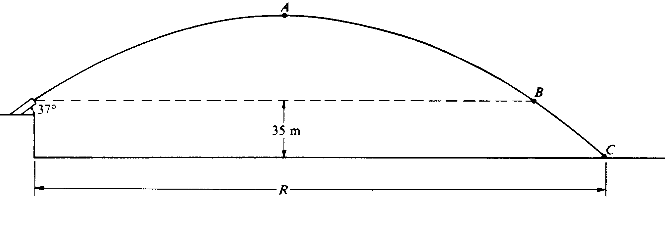
8. (1985 #1) A projectile is launched from the top of a cliff above level ground. At launch the projectile is 35 meters above the base of the cliff and has a velocity of 50 meters per second at an angle 37° with the horizontal. Air resistance is negligible. Consider the following two cases and use g = 10 m/s² sin 37° = 0.60, and cos 37° = 0.80.
Case I: The projectile follows the path shown by the curved line in the following diagram.
a. Calculate the total time from launch until the projectile hits the ground at point C.
b. Calculate the horizontal distance R that the projectile travels before it hits the ground.
c. Calculate the speed of the projectile at points A, B and C.
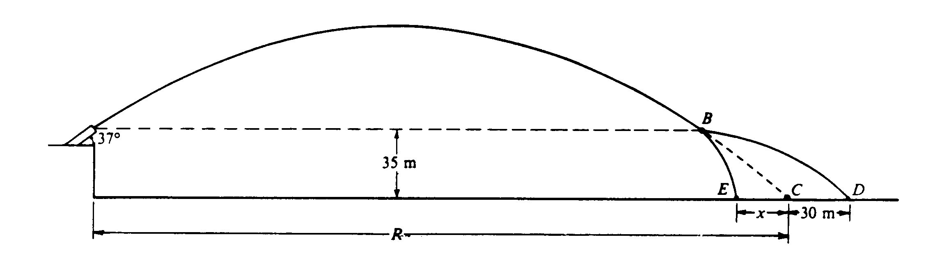Case II: A small internal charge explodes at point B in the following diagram, causing the projectile to separate into two parts of masses 6 kilograms and 10 kilograms. The explosive force on each part is horizontal and in the plane of the trajectory. The 6-kilogram mass strikes the ground at point D, located 30 meters beyond point C, where the projectile would have landed had it not exploded. The 10-kilogram mass strikes the ground at point E.
d. Calculate the distance x from C to E.

