Angular Momentum

1992 #2
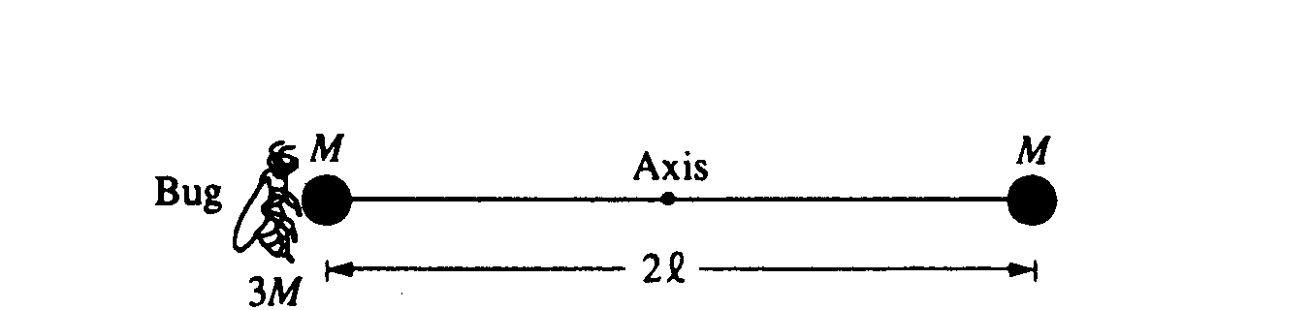
Two identical spheres, each of mass M and negligible radius, are fastened to opposite ends of a rod of negligible mass and length 2l. This system is initially at rest with the rod horizontal, as shown above, and is free to rotate about a frictionless, horizontal axis through the center of the rod and perpendicular to the plane of the page. A bug, of mass 3M, lands gently on the sphere on the left. Assume that the size of the bug is small compared to the length of the rod. Express your answers to all parts of the question in terms of M, l, and physical constants.
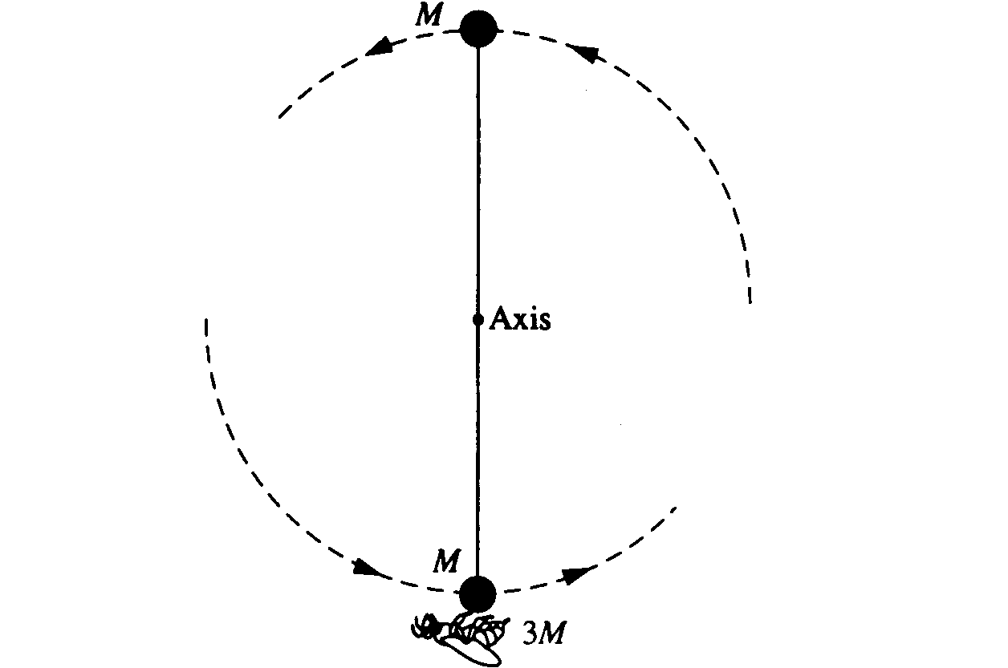
a. Determine the torque about the axis immediately after the bug lands on the sphere.
b. Determine the angular acceleration of the rod-spheres-bug system immediately after the bug lands.

The rod-spheres-bug system swings about the axis. At the instant that the rod is vertical, as shown, determine each of the following.
c. The angular speed of the bug
d. The angular momentum of the system
e. The magnitude and direction of the force that must be exerted on the bug by the sphere to keep the bug from being thrown off the sphere

1998 #2
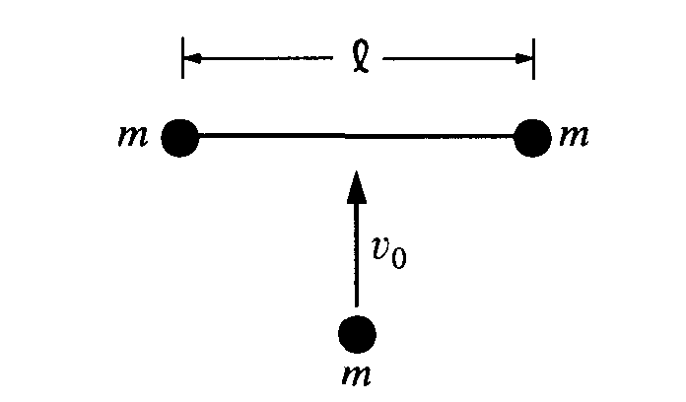
A space shuttle astronaut in a circular orbit around the Earth has an assembly consisting of two small dense spheres, each of mass m, whose centers are connected by a rigid rod of length l and negligible mass. The astronaut also has a device that will launch a small lump of clay of mass m at speed v₀ . Express your answers in terms of m, v₀ l. and fundamental constants.
a. Initially, the assembly is "floating" freely at rest relative to the cabin, and the astronaut launches the clay lump so that it perpendicularly strikes and sticks to the midpoint of the rod, as shown above. i. Determine the total kinetic energy of the system (assembly and clay lump) after the collision. ii. Determine the change in kinetic energy as a result of the collision.

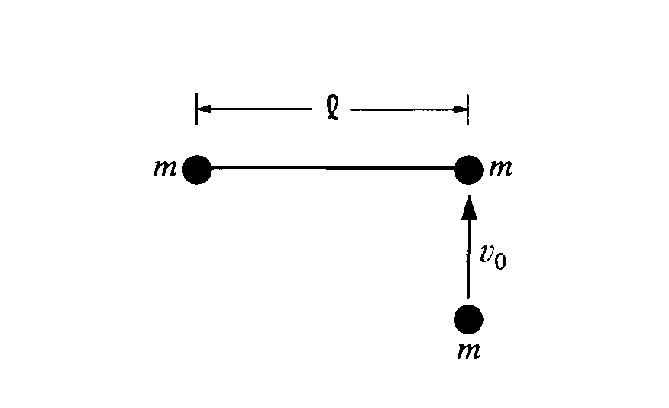
b. The assembly is brought to rest, the clay lump removed, and the experiment is repeated as shown, with the clay lump striking perpendicular to the rod but this time sticking to one of the spheres of the assembly.
i. Determine the distance from the left end of the rod to the center of mass of the system (assembly and clay lump) immediately after the collision. (Assume that the radii of the spheres and clay lump are much smaller than the separation of the spheres.)
ii. On the figure, indicate the direction of the motion of the center of mass immediately after the
collision.
iii. Determine the speed of the center of mass immediately after the collision.
iv. Determine the angular speed of the system (assembly and clay lump) immediately after the collision.
v. Determine the change in kinetic energy as a result of the collision.

2005 #3
ω
M₁
M₂
d
M₁
M₂
v
P
P
Before Collision
After Collision
A system consists of a ball of mass M₂ and a uniform rod of mass M₁ and length d. The rod is attached to a horizontal frictionless table by a pivot at point P and initially rotates at an angular speed ω, as shown. The rotational inertia of the rod about point P is (1/3)M₁d². The rod strikes the ball, which is initially at rest. As a result of this collision, the rod is stopped and the ball moves in the direction shown. Express all answers in terms of M₁, M₂, ω, d, and fundamental constants.
a. Derive an expression for the angular momentum of the rod about point P before the collision.
b. Derive an expression for the speed v of the ball after the collision.
c. Assuming that this collision is elastic, calculate the numerical value of the ratio M₁/M₂.
ω
M₁
M₁
x
P
Before Collision

d. A new ball with the same mass M₁ as the rod is now placed a distance x from the pivot, as shown at right. Again assuming the collision is elastic, for what value of x will the rod stop moving after hitting the ball?

