Rotation 2

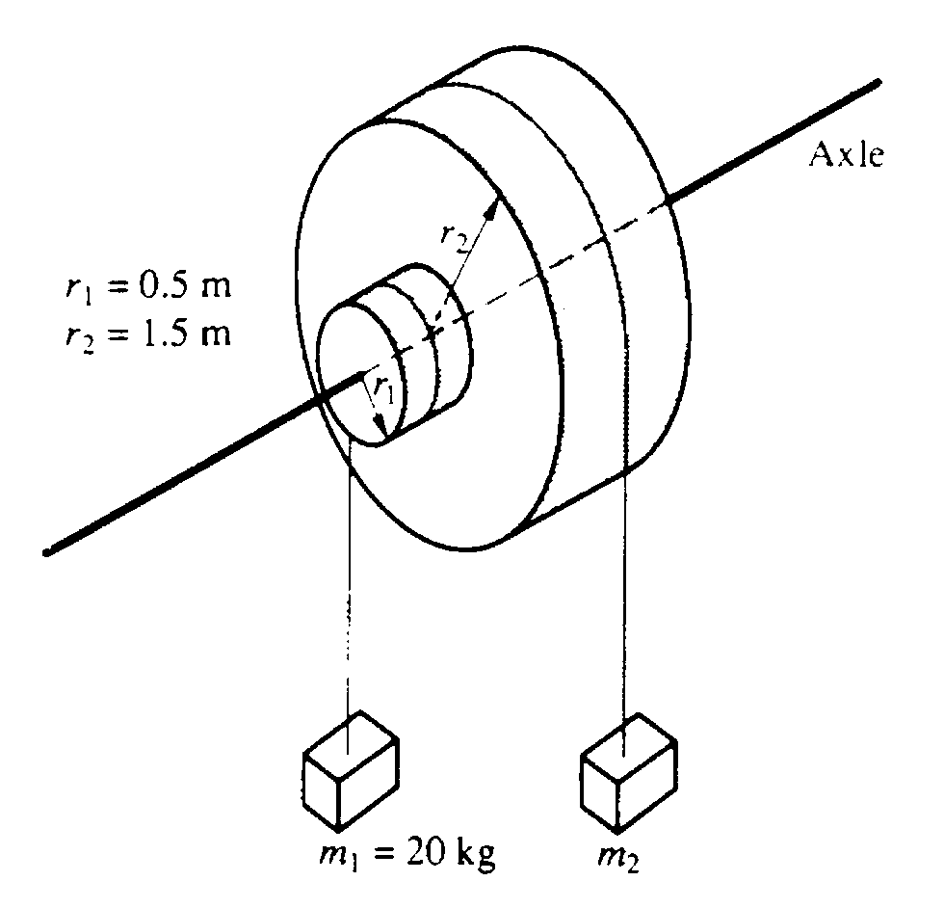
1. Two masses. m₁ and m₂ are connected by light cables to the perimeters of two cylinders of radii r₁ and r₂, respectively. as shown in the diagram above. The cylinders are rigidly connected to each other but are free to rotate without friction on a common axle. The moment of inertia of the pair of cylinders is I = 45 kgm² Also r₁ = 0.5 meter, r₂ = 1.5 meters, and m₁ = 20 kilograms.
a. Determine m₂ such that the system will remain in equilibrium.
The mass m₂ is removed and the system is released from rest.
b. Determine the angular acceleration of the cylinders.
c. Determine the tension in the cable supporting m₁
d. Determine the linear speed of m ₁ at the time it has descended 1.0 meter.

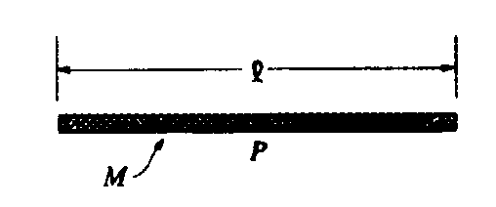
2. Consider a thin uniform rod of mass M and length l, as shown.
a. Show that the rotational inertia of the rod about an axis through its center and perpendicular to its length is Ml²/12 .

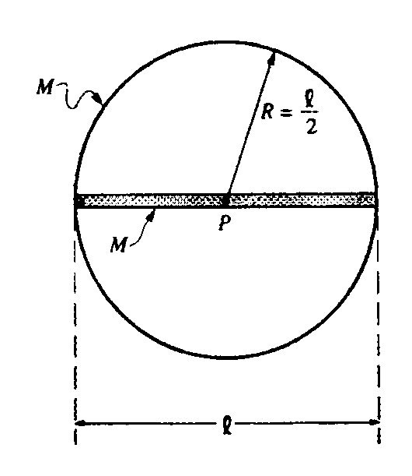
The rod is now glued to a thin hoop of mass M and radius l/2 to form a rigid assembly, as shown above. The centers of the rod and the hoop coincide at point P. The assembly is mounted on a horizontal axle through point P and perpendicular to the page.
b. What is the rotational inertia of the rod-hoop assembly about the axle?

Several turns of string are wrapped tightly around the circumference of the hoop. The system is at rest
when a cat, also of mass M, grabs the free end of the string and hangs vertically from it without swinging
as it unwinds, causing the rod-hoop assembly to rotate. Neglect friction and the mass of the string.
c. Determine the tension T in the string.
d. Determine the angular acceleration a of the rod-hoop assembly.
e. Determine the linear acceleration of the cat.

L
L/3
Pivot

3. A uniform rod of mass M and length L is attached to a pivot of negligible friction as shown. The pivot is located at a distance L/3 from the left end of the rod. Express all answers in terms of the given quantities and fundamental constants.
a. Calculate the rotational inertia of the rod about the pivot.
b. The rod is then released from rest from the horizontal position shown. Calculate the linear speed of the bottom end of the rod when the rod passes through the vertical.

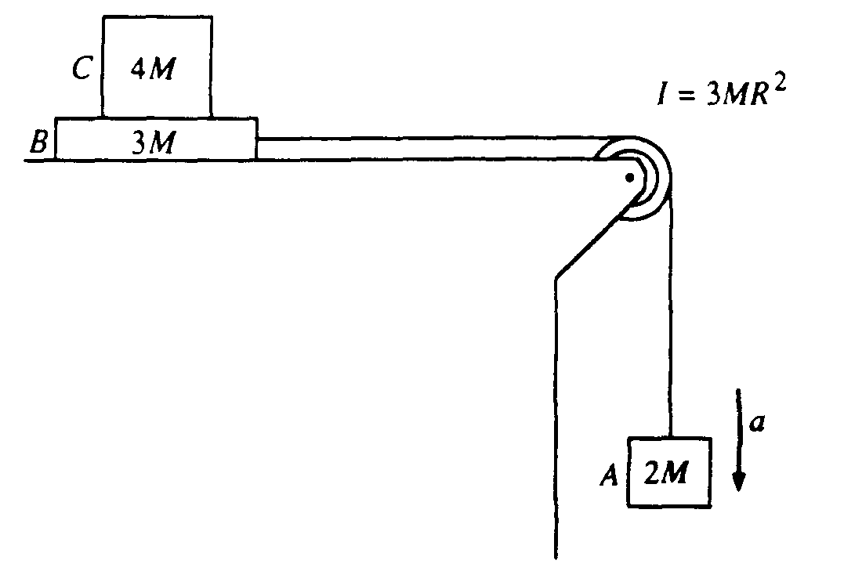
4. Block A of mass 2M hangs from a cord that passes over a pulley and is connected to block B of mass 3M that is free to move on a frictionless horizontal surface, as shown. The pulley is a disk with frictionless bearings, having a radius R and moment of inertia 3MR². Block C of mass 4M is on top of block B. The surface between blocks B and C is NOT frictionless. Shortly after the system is released from rest, block A moves with a downward acceleration a, and the two blocks on the table move relative to each other.

In terms of M, g, and a, determine the
a. tension T_{v} in the vertical section of the cord
b. tension T_{h} in the horizontal section of the cord

If a = 2 meters per second squared, determine the
c. coefficient of kinetic friction between blocks B and C
d. acceleration of block C

5. The two uniform disks shown above have equal mass, and each can rotate on frictionless bearings about a fixed axis through its center. The smaller disk has a radius R and moment of inertia I about its axis. The larger disk has a radius 2R
a. Determine the moment of inertia of the larger disk about its axis in terms of I.
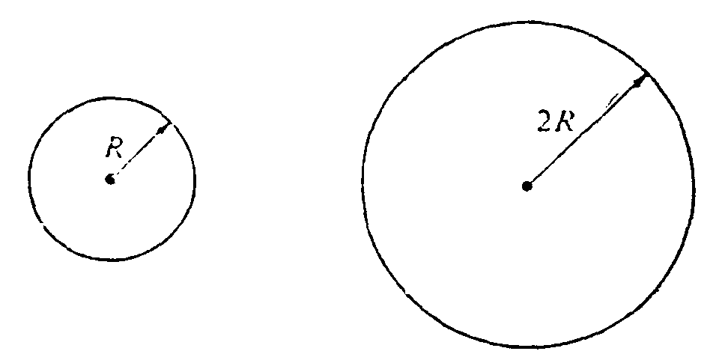

The two disks are then linked as shown below by a light chain that cannot slip. They are at rest when, at time t = 0, a student applies a torque to the smaller disk, and it rotates counterclockwise with constant angular acceleration α. Assume that the mass of the chain and the tension in the lower part of the chain, are negligible.
In terms of I, R, α, and t, determine each of the following:
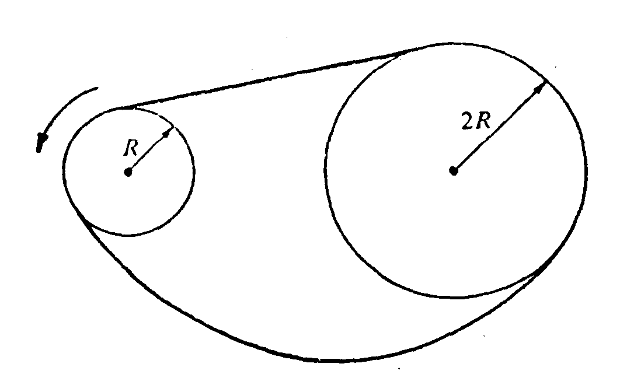
b. The angular acceleration of the larger disk
c. The tension in the upper part of the chain
d. The torque that the student applied to the smaller disk
e. The rotational kinetic energy of the smaller disk as a function of time

