AP Collisions 2
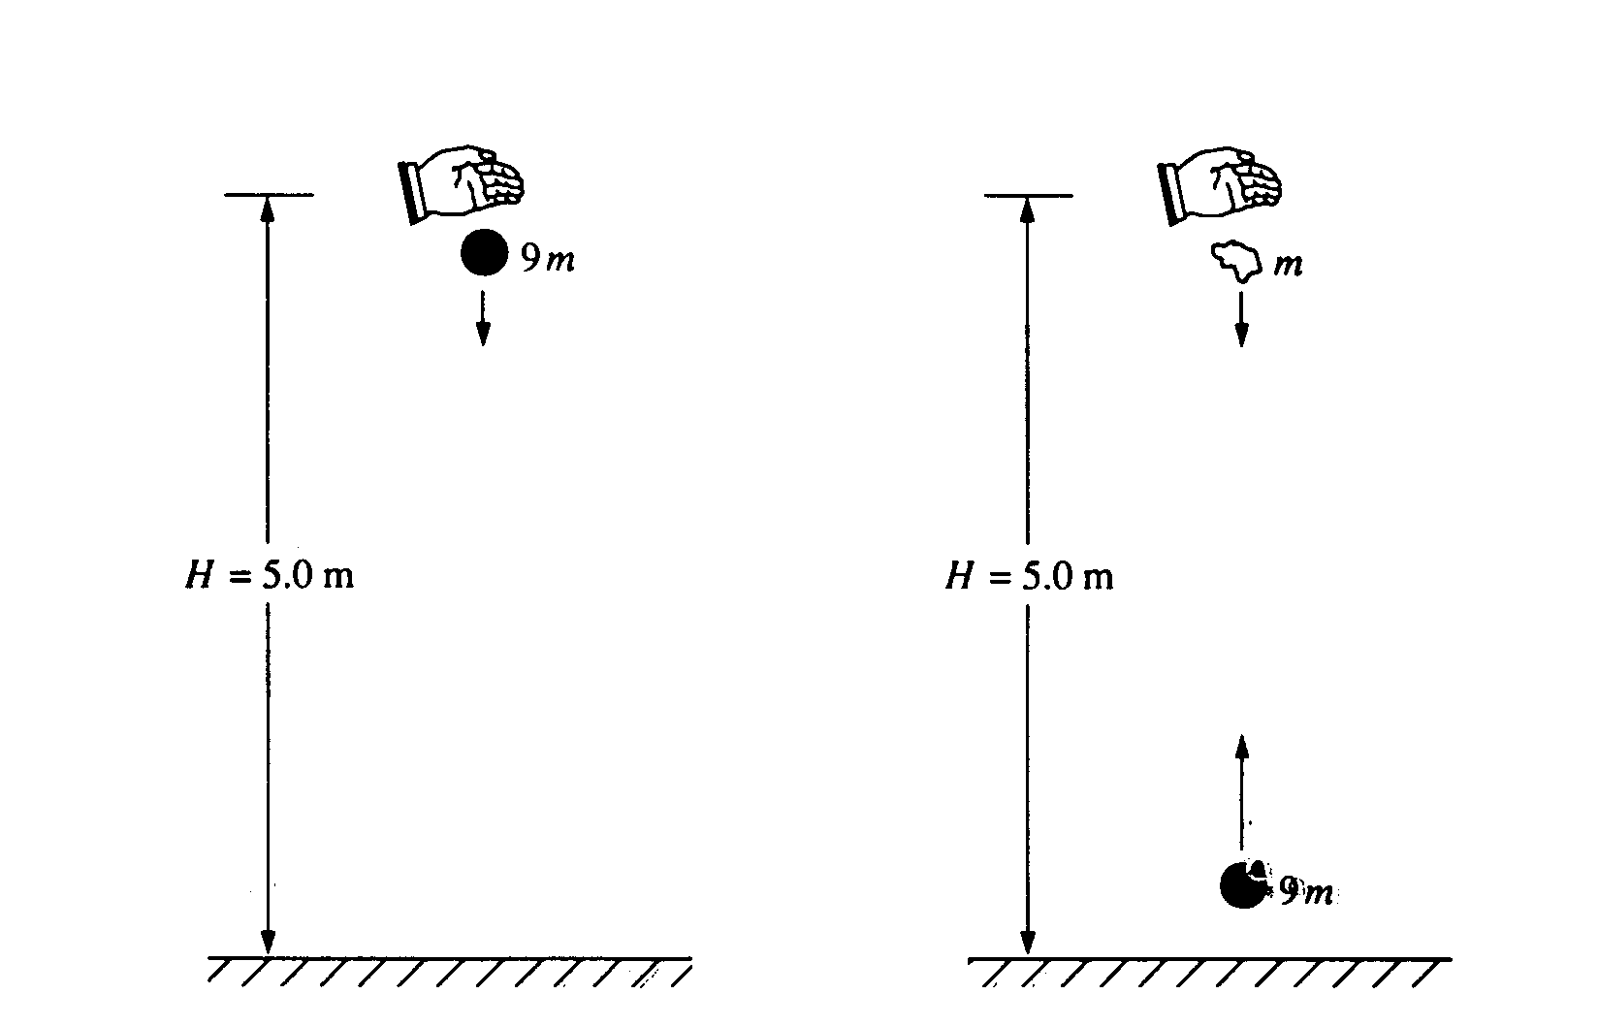
1. A ball of mass 9m is dropped from rest from a height H = 5.0 meters above the ground, as shown above on the left. It undergoes a perfectly elastic collision with the ground and rebounds. At the instant that the ball rebounds, a small blob of clay of mass m is released from rest from the original height H, directly above the ball, as shown above on the right. The clay blob, which is descending, eventually collides with the ball, which is ascending. Assume that g = 10 m/s², that air resistance is negligible, and that the collision process takes negligible time.
a. Determine the speed of the ball immediately before it hits the ground.
b. Determine the time after the release of the clay blob at which the collision takes place.
c. Determine the height above the ground at which the collision takes place.
d. Determine the speeds of the ball and the clay blob immediately before the collision.
e. If the ball and the clay blob stick together on impact, what is the magnitude and direction of their velocity immediately after the collision?
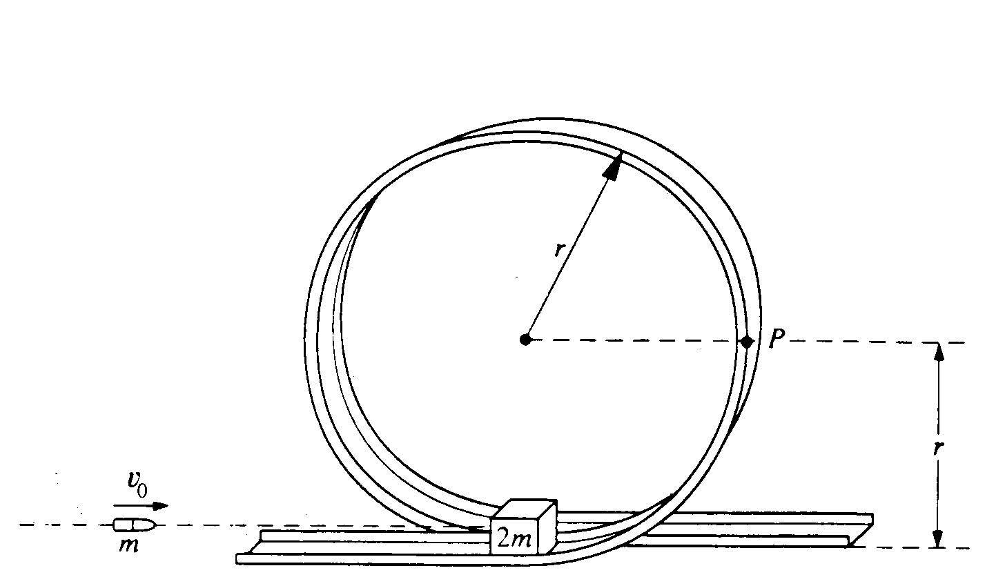
2. A small block of mass 2m initially rests on a track at the bottom of the circular, vertical loop-the-loop shown above, which has a radius r. The surface contact between the block and the loop is frictionless. A bullet of mass m strikes the block horizontally with initial speed v_{o} and remains embedded in the block as the block and bullet circle the loop. Determine each of the following in terms of m, v₀ r, and g.
a. The speed of the block and bullet immediately after impact
b. The kinetic energy of the block and bullet when they reach point P on the loop
c. The minimum initial speed v_{min} of the bullet if the block and bullet are to successfully execute a complete circuit of the loop.

3. A crash test car of mass 1000 kg moving at a constant speed of 12 m/s collides completely inelastically with an object of mass M at time t = 0. The object was initially at rest. The speed v in m/s of the car-object system after the collision is given as a function of time t by the expression
$$v=\frac{8}{1+5t}\text{.}$$
a. Calculate the mass M of the object.
b. Assuming an initial position of x=0, determine an expression for the position of the car-object system after the collision as a function of time t.
c. Determine an expression for the resisting force on the car-object system after the collision as a function of time t.
d. Determine the impulse delivered to the car-object system from t=0 to t=2.0 s.

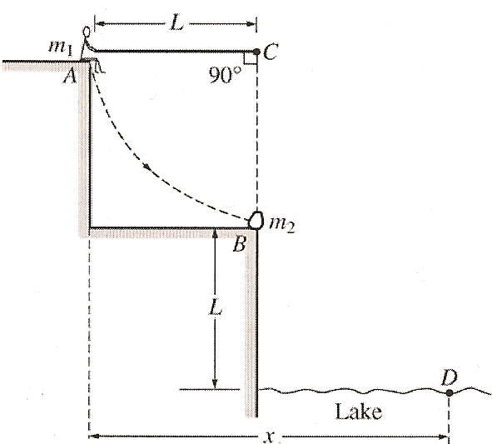
4. A rope of length L is attached to a support at point C. A person of mass m₁ sits on a ledge at position A holding the other end of the rope so that it is horizontal and taut, as shown. The person then drops off the ledge and swings down on the rope toward position B on the lower ledge where an object of mass m₂ is at rest. At position B the person grabs hold of the object and simultaneously lets go of the rope. The person and the object then land together in the lake at point D, which is a vertical distance L below position B. Air resistance and the mass of the rope are negligible. Derive expressions for each of the following in terms of m₁, m₂, L, and g.

a. The speed of the person just before the collision with the object.
b. The tension in the rope just before the collision with the object.
c. The speed of the person and the object just after the collision.
d. The ratio of the kinetic energy of the person-object system before the collision to the kinetic energy after the collision.
e. The total horizontal displacement x of the person from position A until the person and the object land in the water at point D.

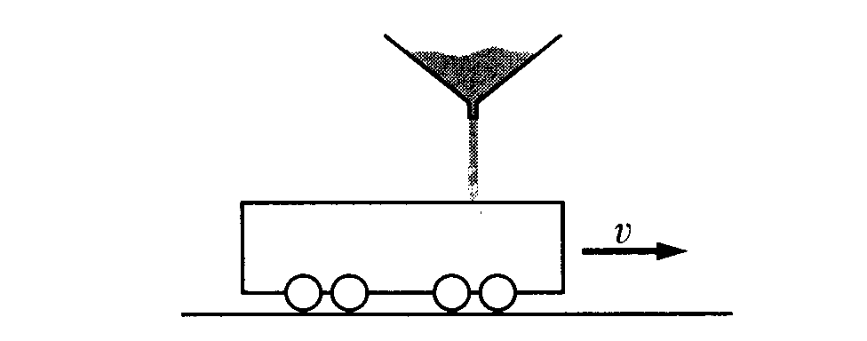
5. An open-top railroad car (initially empty and of mass M_{o}) rolls with negligible friction along a straight horizontal track and passes under the spout of a sand conveyor. When the car is under the conveyor, sand is dispensed from the conveyor in a narrow stream at a steady rate ΔM/Δt = C and falls vertically from an average height h above the floor of the railroad car. The car has initial speed v_{o} and sand is filling it from time t = 0 to t = T. Express your answers to the following in terms of the given quantities and g.
a. Determine the mass M of the car plus the sand that it catches as a function of time t for 0 < t < T.
b. Determine the speed v of the car as a function of time t for 0 < t < T.
c. i. Determine the initial kinetic energy K_{i} of the empty car.
ii. Determine the final kinetic energy K_{f} of the car and its load.
iii. Is kinetic energy conserved? Explain why or why not.
d. Determine expressions for the normal force exerted on the car by the tracks at the following times.
i. Before t = 0
ii. For 0 < t < T
iii. After t = T

