AP Collisions 1
1. A 100 kg running back jumps to score a touchdown. He is traveling 8 m/s just before the goal line when he is hit by a 115 kg linebacker traveling 7 m/s in the opposite direction. They stick together following the collision.
a. What is the final speed of the combination?
b. What direction do they travel after the collision? (Does he score a touchdown?)
c. What type of collision is this?

2. A 4 kg block is sliding along a frictionless surface at 5 m/s when it hits a 3 kg block that is traveling in the opposite direction at 2 m/s. After the collision, the 4 kg block is traveling 1 m/s in its original direction.
a. What is the initial momentum of the system?
b. What is the initial kinetic energy of the system?
c. What is the final velocity of the 3 kg block?
d. What is the final kinetic energy of the system?
e. What type of collision is this?

3. Two 1.5 kg blocks are traveling toward each other when they collide elastically. One is traveling 4 m/s to the right, while the other is traveling 3 m/s to the left.
a. What is the initial momentum of the system?
b. What is the initial kinetic energy of the system?
c. What is the final momentum of the system?
d. What is the final kinetic energy of the system?
e. What is the final velocity (speed and direction) of each block?

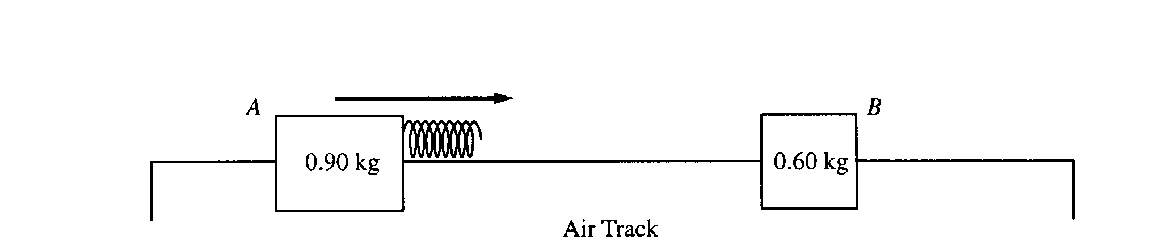
4. Two gliders move freely on an air track with negligible friction, as shown. Glider A has a mass of 0.90 kg and glider B has a mass of 0.60 kg. Initially, glider A moves toward glider B, which is at rest. A spring of negligible mass is attached to the right side of glider A. Strobe photography is used to record successive positions of glider A at 0.10 s intervals over a total time of 2.00 s, during which time it collides with glider B.

The following diagram represents the data for the motion of glider A. Positions of glider A at the end of each 0.10s interval are indicated by the symbol A against a metric ruler. The total elapsed time t after each 0.50 s is also indicated.

a. Determine the average speed of glider A for the following time intervals.
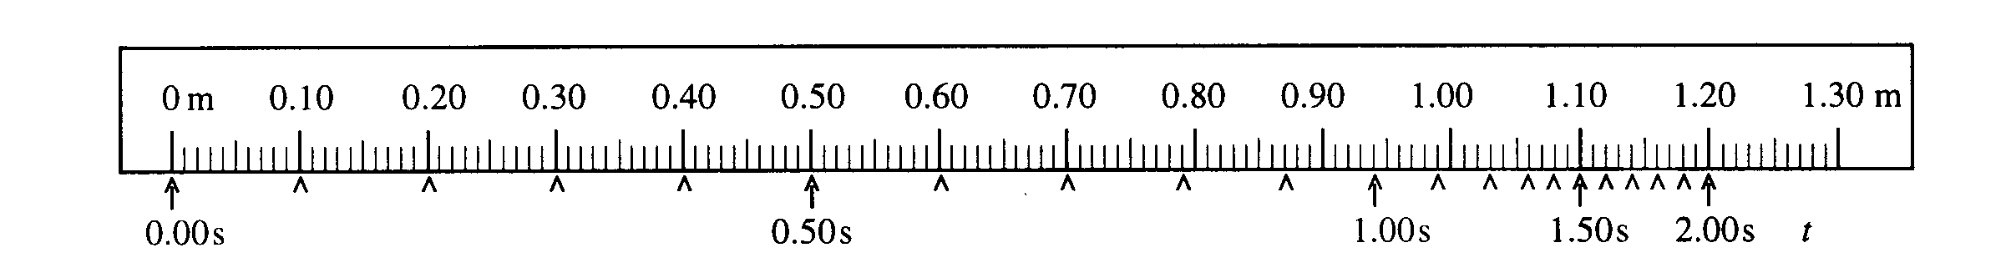 i. 0.10 s to 0.30 s ii. 0.90 s to 1.10 s iii. 1.70 s to 1.90 s

b. On the axes below, sketch a graph, consistent with the data above, of the speed of glider A as a function of time t for the 2.00 s interval.

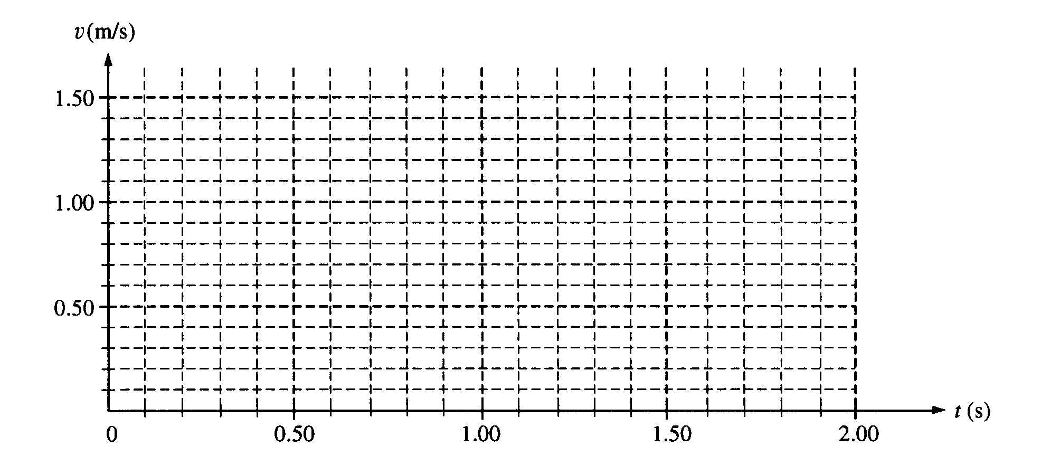
c. i. Use the data to calculate the speed of glider B immediately after it separates from the spring.
ii. On the axes below, sketch a graph of the speed of glider B as a function of time t.
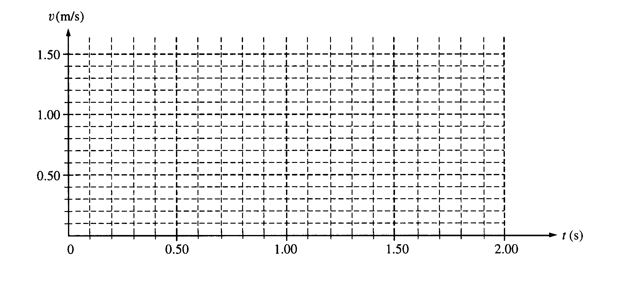A graph of the total kinetic energy K for the two-glider system over the 2.00 s interval has the following shape. K_{o} is the total kinetic energy of the system at time t = 0.
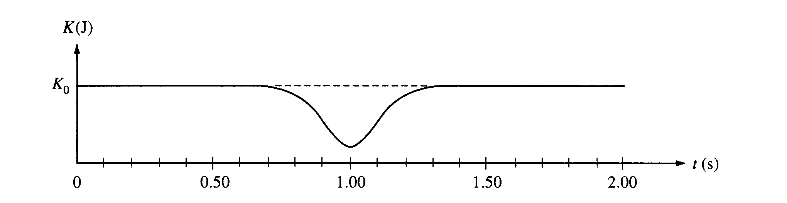
d. i. Is the collision elastic? Justify your answer.

ii. Briefly explain why there is a minimum in the kinetic energy curve at t = 1.00 s.

