AP Even More Work
1988 #2

A 5-kilogram object initially slides with speed v_{o} in a hollow frictionless pipe. The end of the pipe contains two springs. one nested inside the other, as shown above. The object makes contact with the inner spring at point A, moves 0.1 meter to make contact with the outer spring at point B, and then moves an additional 0.05 meter before coming to rest at point C. The graph shows the magnitude of the force exerted on the object by the springs as a function of the objects distance from point A.
5kg
V₀
A
B
C
0.10 m
0.05 m
0
0.05
0.10
0.15
60
40
20
80
F
o
r
c
e (N)
Distance (m)
a. Calculate the spring constant for the inner spring.
b. Calculate the decrease in kinetic energy of the object as it moves from point A to point B.
c. Calculate the additional decrease in kinetic energy of the object as it moves from point B to point C.
d. Calculate the initial speed v_{o} of the object
e. Calculate the spring constant of the outer spring

1986 #1
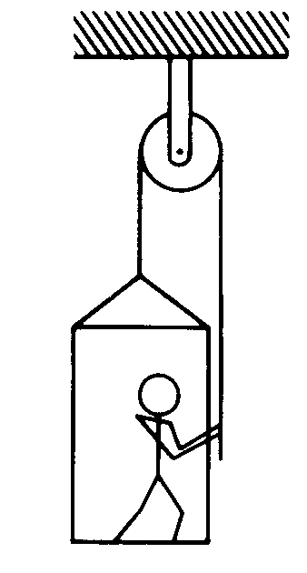
The figure above shows an 80-kilogram person standing on a 20-kilogram platform suspended by a rope passing over a stationary pulley that is free to rotate. The other end of the rope is held by the person. The masses of the rope and pulley are negligible. You may use g = 10 m/ s². Assume that friction is negligible, and the parts of the rope shown remain vertical.
a. If the platform and the person are at rest, what is the tension in the rope?

The person now pulls on the rope so that the acceleration of the person and the platform is 2 m/s² upward.
b. What is the tension in the rope under these new conditions?
c. Under these conditions, what is the force exerted by the platform on the person?

After a short time, the person and the platform reach and sustain an upward velocity of 0.4 m/ s.
d. Determine the power output of the person required to sustain this velocity.

2003 #1
A 100 kg box shown above is being pulled along the x-axis by a student. The box slides across a rough surface, and its position x varies with time t according to the equation $x=0\text{.}5t^{3}+2t$, where t is in seconds.
100 kg
a. Determine the speed of the box at time t = 0.
b. Determine the following as functions of time t.
i. The kinetic energy of the box
ii. The net force acting on the box
iii. The power being delivered to the box
c. Calculate the net work done on the box in the interval t = 0 to t = 2s.
d. Indicate below whether the work done on the box by the student in the interval t = 0 to t = 2 s would be greater than, less than or equal to the answer in part (c).
____ Greater than ____ Less than ____ Equal to
Justify your answer.

